

**Client-side Interface for a**

**Web-based Project Management System**

**Submitted by Celia Ong Si Le**

**Matriculation Number: U1621971K**

**Supervisor: Assoc Prof Chua Hock Chuan**

School of Electrical & Electronic Engineering

A final year project report presented to the Nanyang Technological University

in partial fulfilment of the requirements of the degree of

Bachelor of Engineering

**2020**

Table of Contents

Abstract i

List of Figures ii

List of Tables v

Chapter 1: Introduction 1

1.1 Background 1

1.2 Motivation 2

1.3 Objectives and Scope 2

1.4 Accomplishment 3

1.5 Organization of thesis 3

Chapter 2: Literature Review 5

2.1 Visual Inspirations 5

2.1.1 Microsoft Outlook Calendar 5

2.1.2 Google Calendar 5

2.2 User Interface (UI) 6

2.2.1 Typography 6

2.2.1.2 Type classification 6

2.2.1.2.1 Serif 6

2.2.1.2.2 Sans Serif 7

2.2.2 Color Palette 7

2.2.3 Design Principles 7

2.2.3.1 Balance 7

2.2.3.2 Rhythm 7

2.2.3.3 Dominance 7

2.2.3.4 Proximity 8

2.3 Frontend Development Framework 8

2.3.1 ReactJS 8

2.3.2 Material-UI 8

2.3.3 Web Application Programming Interface (API) 9

2.3.4 Promises and how to fetch them 10

2.3.5 State Management 11

2.3.6 React Router 12

2.3.7 Moment.js 13

Chapter 3: Project Implementation 15

3.1 Design Requirements 15

3.1.1 Authentication 15

3.1.2 Calendar View 16

3.1.3 Reports View 16

3.1.3.1 Weekly Report Submission 17

3.1.3.2 Meeting Notes 17

3.1.3.3 Other Submissions 18

3.1.4 Page Layout 18

3.1.5 Determining the routing in the application 18

3.2 Design Process 19

3.2.1 Low-Fidelity Design 20

3.2.1.1 Calendar View 20

3.2.1.2 Reports View 20

3.2.1.2.1 Weekly Report and Meeting Notes View 20

3.2.1.2.2 Other Submissions View 23

3.2.2 High-Fidelity Design 24

3.2.2.1 Sign-In View 24

3.2.2.2 Calendar View 25

3.2.2.3 Reports View 27

3.2.2.3.1 Weekly Report View 27

3.2.2.3.2 Meeting Notes View 28

3.2.2.3.3 Other Submissions View 30

3.2.3 Component Design 31

3.2.3.1 Sign-In View 31

3.2.3.2 Calendar View 32

3.2.3.3 Reports View 32

3.2.3.3.1 Weekly Report View 33

3.2.3.3.2 Meeting Notes View 33

3.2.3.3.3 Other Submission View 34

3.2.4 Design Decisions 35

3.2.4.1 Theme & Color Palette 35

3.2.4.2 Typography 36

Chapter 4: Results and Discussions 37

4.1 Authentication 37

4.2 Calendar View 38

4.2.1 Deciding on a calendar library 38

4.2.2 Retrieving the data to the client-side 39

4.2.3 Calendar View and Functionalities 41

4.2.3.1 Similar Functionalities 42

4.2.3.1.1 Adding and Deleting events 42

4.2.3.1.2 Summarized view of events 44

4.2.3.2 Different Functionalities 45

4.2.3.2.1 Left-Side Drawer 45

4.2.3.2.2 Filtering of projects 46

4.3 Reports View 47

4.3.1 Write and Upload Content 48

4.3.2 Uploading Documents 50

4.3.3 View Uploaded Documents 51

4.3.4 Comment Section 52

Chapter 5: Conclusions and Future Work 55

5.1 Conclusions 55

5.2 Recommendation in Future Work 55

5.2.1 Notification System 56

5.2.2 Automatic Update of Statuses 56

5.2.3. Announcements System 56

References 1

# Abstract

In this report, I will be covering what it takes to build the interface for a web-based project management system for supervisors and students in NTU taking a Final Year Project (FYP) or groups of students taking the Design Innovation Project (DIP) module. A strong emphasis on ReactJS and user interface design choices will be discussed here.

The system will be a crucial application to help convey important materials and to boost the efficiency of contact between supervisors and their students.

This project’s interface is built on React, a frontend library in JavaScript along with Material-UI, HTML and CSS for styling of design components as well as other libraries like Axios to call APIs and Moment.js as a date utility library. The developed client-side user interface will provide the best user experience by containing user friendly interfaces along with carefully planned Web Architecture like the Single-Page Application (SPA) framework.

# List of Figures

Figure 1: Microsoft Outlook Calendar 5

Figure 2: Google Calendar 6

Figure 3: Page layout of platform 18

Figure 4: Categorizing Routes with Conditionals 19

Figure 5: Low-Fi Main Calendar Design 20

Figure 6: Low-Fi Weekly Report Design Version 1 21

Figure 7: Low-Fi Weekly Report Version 2 22

Figure 8: Low-Fi Weekly Report with Expansion Panels 23

Figure 9: Low-Fi Other Submissions Design 24

Figure 10: Hi-Fi Sign-In Design 24

Figure 11: Hi-Fi Main Calendar Design 25

Figure 12: Hi-Fi Main Calendar Add Event Design 26

Figure 13: Hi-Fi Weekly Report Design 27

Figure 14: Hi-Fi Weekly Report Design – w/ Content vs w/o 27

Figure 15: Hi-Fi Meeting Notes Design w/ Attachments 28

Figure 16: Hi-Fi Meeting Notes Design w/o Attachments 29

Figure 17: Hi-Fi Meeting Notes Condensed Design 29

Figure 18: Hi-Fi Other Submissions w/o Submissions Design 30

Figure 19: Hi-Fi Other Submissions w/ Submissions Design 30

Figure 20: Hi-Fi Other Submissions w/ Comment Section Design 31

Figure 21: Sign-In Component Breakdown 32

Figure 22: Main Calendar Component Breakdown 32

Figure 23: Weekly Report Component Breakdown 33

Figure 24: Meeting Notes Component Breakdown 34

Figure 25: Other Submissions Component Breakdown 35

Figure 26: Colour Palette for Platform 36

Figure 27: Sign-In Component 38

Figure 28: Sign-In Error Message 38

Figure 29: TaskComment API 40

Figure 30: Supervisor Calendar 41

Figure 31: Student Calendar 41

Figure 32: Supervisor's Add Event Form 42

Figure 33: Student's Add Event Form 42

Figure 34: Types of events 43

Figure 35: Types of projects (for Supervisor only) 43

Figure 36: Summarized view of events 43

Figure 37: Simplified symbolism of events 44

Figure 38: Summarized view shows status 44

Figure 39: Supervisor's left-side drawer 45

Figure 40: Student's left-side drawer 46

Figure 41: Supervisor filters out “Interactive Display” 46

Figure 42: Supervisor filters out “Web App Management Project” 47

Figure 43: Student view of weekly report 48

Figure 44: Supervisor view of weekly report 49

Figure 45: Supervisor view of meeting notes 49

Figure 46: Displaying total number of hours 49

Figure 47: Uploading more documents after submission 50

Figure 48: More files are uploaded 50

Figure 49: The .pdf view when opened up 51

Figure 50: The .docx view when opened up 51

Figure 51: Viewing of comments 52

Figure 52: Comment button before comments are added 53

Figure 53: API ties all comments to 1 task instead of document ID 53

Figure 54: Multiple documents, 1 comment section 54

Figure 55: View when comment section is closed 54

# List of Tables

Table 1: HTTP Verbs Example 10

Table 2: Differences between Fetch and Axios 11

Table 3: Differences between MobX and Redux 12

Table 4: React Router Components 13

Table 5: Moment.js Functions 14

Table 6: A comparison of type of reports to their functionalities 48



# Introduction

## 1.1 Background

Since 1997, Singapore has taken the approach of ‘Thinking Schools, Learning Nation’. A vision launched by then Prime Minister Goh Chok Tong [1]. This has led to a curriculum review where an Integrated Project Work (IPW) program was recommended. Students would complete assignments that required research or problem solving in groups or individually. This is to encourage young Singaporeans to perceive education as a life-long process and to develop creative thinking skills and a lifelong passion for learning, which are important traits for an engineer.

Therefore, this has no doubt played a vital role in the education systems within autonomous universities such as Nanyang Technological University. In the School of Electrical and Electronic Engineering (EEE) alone, there are 2 compulsory project-based assessments for full-time students, the Design and Innovation Project (DIP) taken by full-time third year students and the Final Year Project (FYP) by final year students.

The DIP module lasts 1 semester and usually contains 8-10 students with a group leader and a treasurer. As a group, they will be tasked to complete a project that requires them to merge hardware, software and design to develop a solution that tackles the problem.

FYP on the other hand is 2 semesters long that are usually individually based projects with a few exceptions. Students are assigned projects based on their field of study and interests towards the project.

For both cases, there will be a supervisor that will guide and advice the student(s) undertaking the projects.

## 1.2 Motivation

Project management systems have grown bigger and better of late. With software like *monday.com* and *Kanbanize* that aims to revolutionize the way teams work in projects by facilitating project deliveries and making it more efficient, those systems are also getting more complex. Without a doubt, those software include many functionalities to suit different users, however, what we aim to do with this FYP is to apply a similar goal – to facilitate project delivery and accountability, by simplifying what is available and personalizing it to fit our needs.

We envision building a web-based system that is personalized to what professors in Nanyang Technological University (NTU) will require when they are handling FYP and/or Design and Innovation Project (DIP) students.

## 1.3 Objectives and Scope

This Final Year Project is aimed at designing a good client-side user interface (UI) for a project management platform for FYP and DIP students. It will focus on the user interface, user experience and using ReactJS to bring it all to life.

Every student (or group leader for DIP modules) will have their own events in a calendar. Each event is mapped to a task or a report that is needed to be submitted. The events can be added by any user to reduce the managerial burden on an academic supervisor for every single project they oversee. The calendar, tasks and report submissions are accessible by the student and their supervisor – there will be a login page to authenticate the user and determine the type of user.

Currently, the progress of FYPs and DIPs are conducted through emails, in-person meetings and other modes of communication. Each supervisor would have to make a date with their students to meet bi-weekly and these students will update their professor on the progress on a weekly basis through a weekly report submission.

As such, there is no standing operating procedure as to how each supervisor and student tracks and updates their progress.

Therefore, this platform should be able to support supplementary features like:

1. Single-Page Application (SPA) using ReactJS
2. Optimal navigation system, likely a 3-click to destination rule
3. Overview of all calendar-based events and statuses
4. Ability to create, update and delete tasks and events
5. File sharing system for relevant documents to be shared
6. Comment section for users to comment on whichever task

## 1.4 Accomplishment

I have successfully developed said project management platform for students and supervisors taking FYP and DIP modules. This platform will allow supervisors to request for reports by adding an event in the calendar that is automatically converted as a task. A deadline is attached with each event/task and a status is too.

There are 4 statuses for each task:

1. Completed: Submitted on time
2. Late: Submitted late
3. Late Submission: Did not submit and due date has passed
4. Pending: Due date has not arrived yet

The status for each event changes depending on whether the student has submitted what is required before the deadline has passed. There is a file sharing platform for extra documents to be attached to any task and viewed by either authenticated party. There is also a comment section to allow for feedback from either party on any task.

## 1.5 Organization of thesis

In the first chapter, it covers the motivation, objectives and scope of the project.

In the second chapter, a literature review will be conducted on the reference materials and technical considerations of the project.

In the third chapter, the project’s implementation will be broken down based on design requirements and the design process.

In the fourth chapter, it covers the results and discussions including the various functionalities and final views.

And finally, the conclusion wraps up along with the recommendation of future works.

# 

# Literature Review

## 2.1 Visual Inspirations

In order for us to begin designing any platform, we have to look for inspirations that can guide us in the right direction of our end product. This meant looking at 2 major platforms: Microsoft’s Outlook Calendar and Google Calendar.

### 2.1.1 Microsoft Outlook Calendar

Microsoft Outlook Calendar is chosen as an inspiration as it is a commonly used platform by supervisors when handling work-related events.

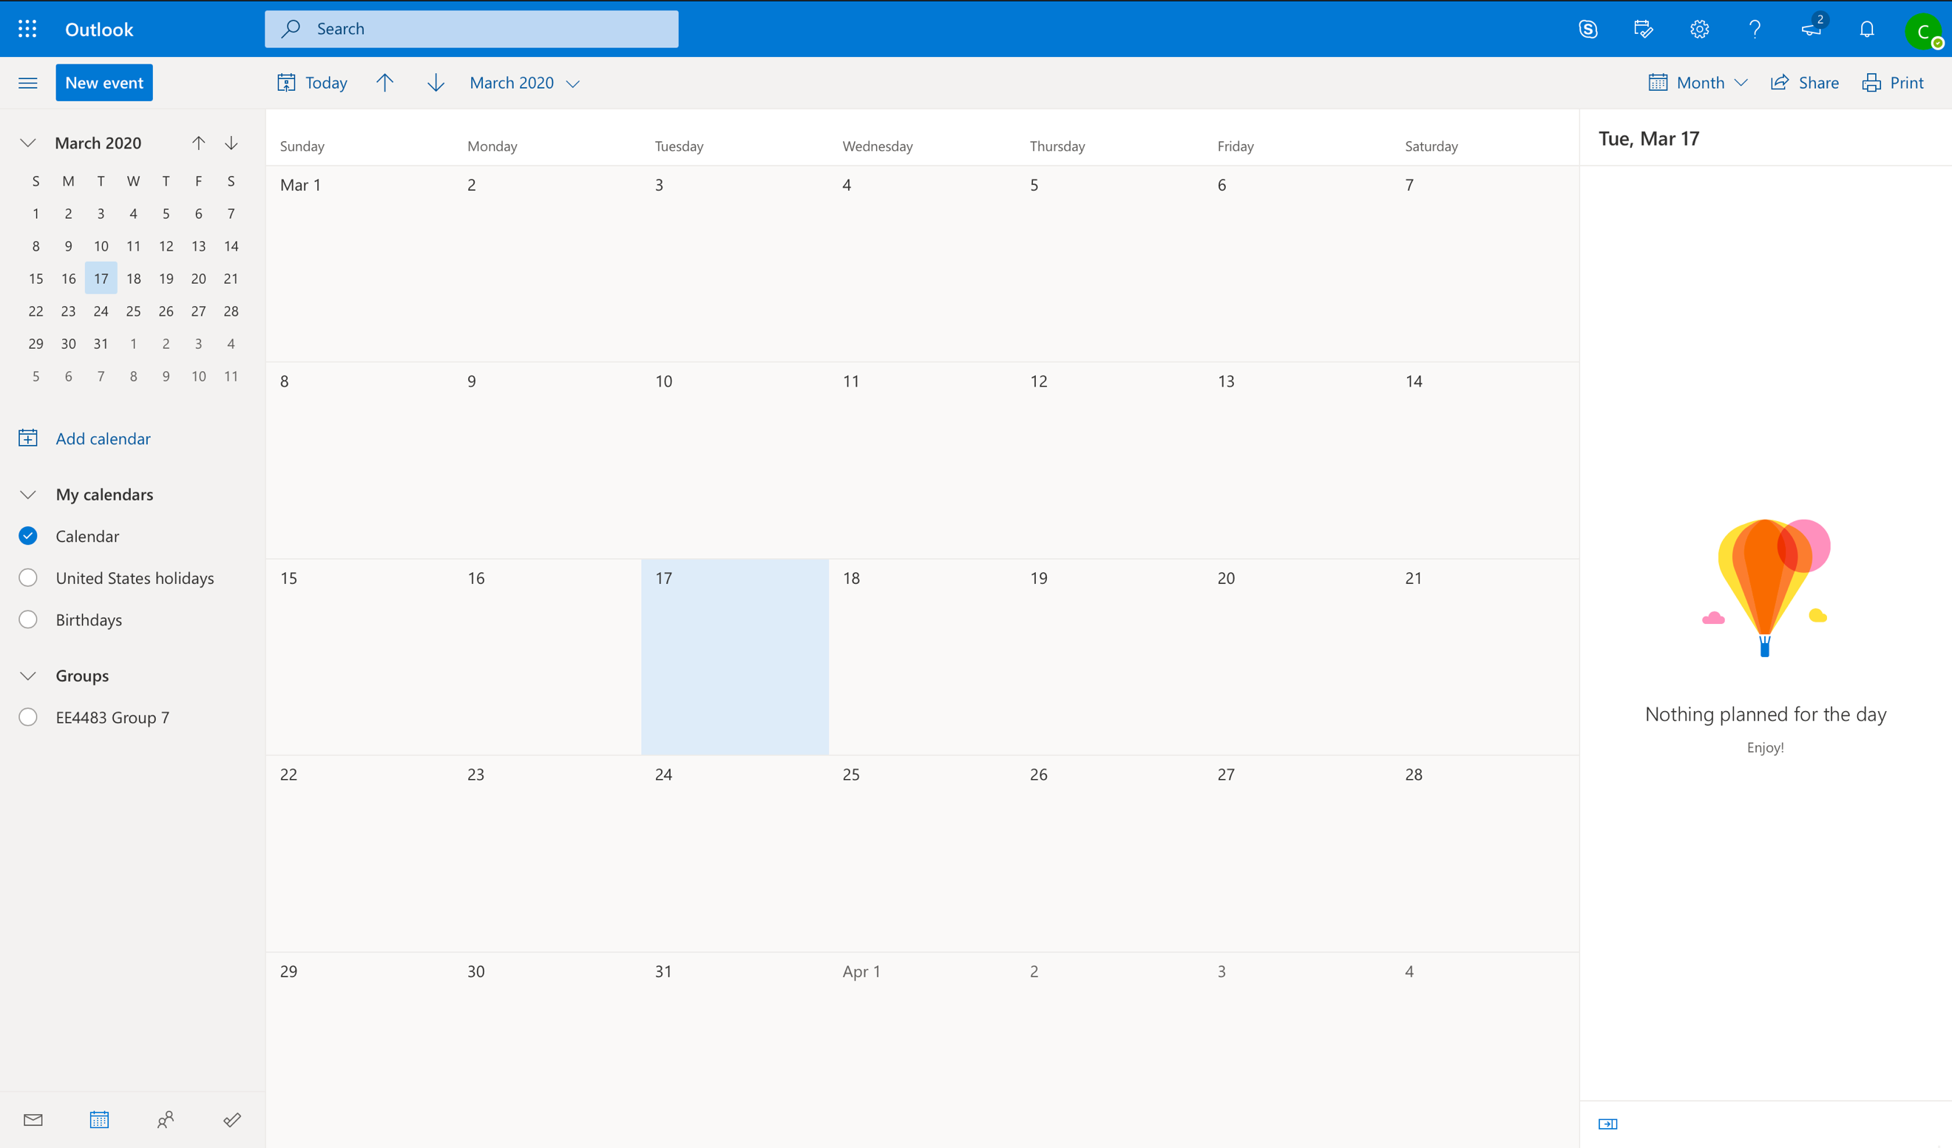

Figure 1: Microsoft Outlook Calendar

It is developed by Microsoft and is part of their Microsoft Office 365 Suite [2] which NTU students and personnel has access to.

### 2.1.2 Google Calendar

Google Calendar is also another inspiration because it is developed by Google, a leading tech giant in the field of technology and design. Having created their own library called Material Design to standardize components, they aim to combine classical principles of good design backed with technology and science [3].

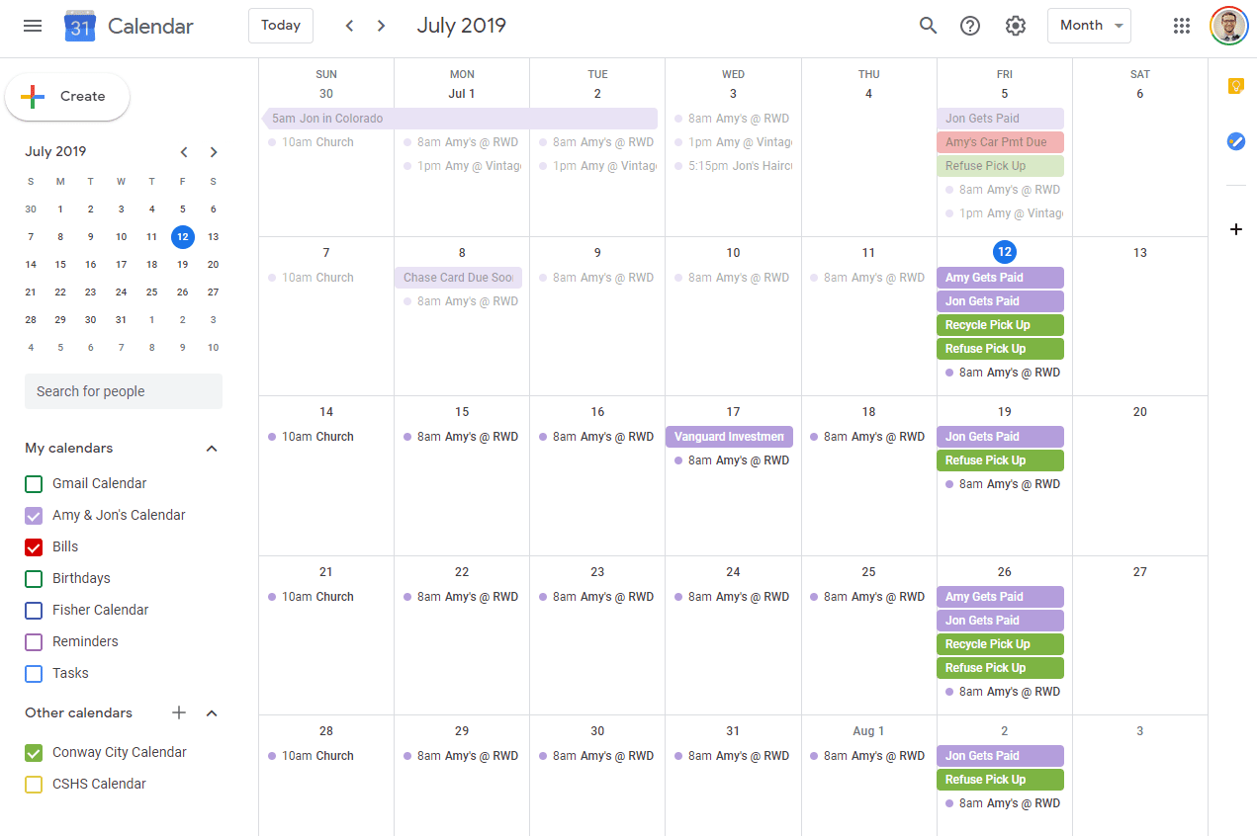

Figure 2: Google Calendar

Both calendars allow adding of events, scheduling them and adding people into the events to keep them informed.

## 2.2 User Interface (UI)

### 2.2.1 Typography

A typeface is a collection of letters. Typefaces that are selected for their style, legibility and readability are most effective when following the fundamental principles of typographic design [4].

#### 2.2.1.2 Type classification

##### 2.2.1.2.1 Serif

A serif is a small shape or projection that appears at the beginning or end of a stroke on a letter. For example, Garamond and Libre Baskerville.

##### 2.2.1.2.2 Sans Serif

A typeface without serifs are called “sans serif”, where “sans” means “without” in French. Examples of such typefaces include Futura and Roboto.

### 2.2.2 Color Palette

A color palette is a collection of colors put together because they complement each other well. In UI design, a palette can consist of a primary and a secondary palette. Primary palettes are usually for the main crux of all your designs whereas a secondary palette is used for an action that does not conform with the intended usage (for example an error message).

Being able to find a good color palette is important. A UI designer should be able to take into account the functionality, feedback, contrast, legibility and color blindness of the entire platform.

### 2.2.3 Design Principles

A few design principles governing some rules on how to design interfaces are as follows:

#### 2.2.3.1 Balance

It is the idea of arranging elements and negative space so that no one area of the design overpowers the others [5].

#### 2.2.3.2 Rhythm

Rhythm occurs when intervals between elements are predictable and when the elements repeat at regular intervals. This helps users to infer what the elements are and understand what they do quickly [6].

#### 2.2.3.3 Dominance

Dominance enables and directs the user’s flow. It relies on contrast – a clear difference in the visual field to let people know what’s important and where they should look first. It is not always about size but more so about contrast, placement and appearance [7].

#### 2.2.3.4 Proximity

It is the distance between visual elements. It is used to signal relationships between the elements. The closer they are, the more related they are in terms of usage. This helps people to recognize things faster [8].

## 2.3 Frontend Development Framework

### 2.3.1 ReactJS

ReactJS is a Javascript library for building user interfaces, maintained by Facebook. It is declarative and component based. Declarative views make the code more predictable and easier to debug whereas building in encapsulated components that has their own states and props allow us to make complex user interfaces [9].

It is primarily used for creating views that is rendered in HTML and is unique for its virtual Document Object Model (DOM) – which is the heart of all modern interactive web application as it responds to any user interface changes – compared to a typical server rendered viewed that uses that typical DOM manipulation.

React also makes full use of components, which are the fundamental building blocks of the React framework. Each component maintains and renders their own states. They are responsible for storing the state of its view and renders independently of each other.

These components can communicate with each other by sharing state information from parent components by way of passing these states into props. This makes application writing much simpler and modular.

### 2.3.2 Material-UI

In order to create UI systems, we use a React UI framework, Material-UI so that we can cut down on building components from scratch and can instead simply import different components we require and tweaking the CSS to match our designs.

For example, a drawer component is complex to create from scratch, however with Material-UI, we just need to import Drawer and use it as <Drawer /> and a drawer will appear.

The reasons towards choosing this UI framework is because:

1. It follows closely to Material Design’s framework (supported by Google), but Material-UI uses ReactJS (in which Google uses AngularJS)
2. It is well-documented and constantly updated
3. It has a strong support system of talented developers resolving any issues that may pop up
4. It has been used by multiple major organizations such as NASA, J.P. Morgan, Amazon and more [10]

### 2.3.3 Web Application Programming Interface (API)

An Application Programming Interface (API) is a documented communication protocol for interaction between various web services. It is a middleman between the backend and frontend, allowing them to communicate with each other [11].

Separately, Representational State Transfer (REST) is an architectural principal where the server and client can interact without the client knowing much about the server and the resources it carries.

Important principles of a RESTful API involves separating the API into logical resources. These resources are manipulated using HTTP verbs like PUT, GET, DELETE and POST. The list below displays the most commonly used HTTP verbs and requests and their respective actions, in terms of this project.

|  |  |  |  |
| --- | --- | --- | --- |
| **HTTP Verb** | **What it does** | **URI** | **Description** |
| GET | Retrieving a set of existing resources from database | /api/taskComment | It gets the entire list of task objects from the database |
| PUT | Updates an existing resource | /api/taskComment/{task_id}/ | It updates the task with the task_id as indicated |
| DELETE | Deletes an existing resource | /api/taskComment/{task_id}/ | It deletes a task with the task_id as indicated |
| POST | Creating a new resource | /api/taskComment | It creates a new task, generating a new task_id automatically. The type of task is dependent on what parameters are passed through. |

Table 1: HTTP Verbs Example

### 2.3.4 Promises and how to fetch them

A Promise object represents the eventual completion (or failure) of an asynchronous operation and its resulting value [12]. It has 3 states: Pending, Fulfilled and Rejected. It is used as a “package” to wrap around the data that’s supposed to be gotten through HTTP requests. If the package is delivered successfully, the Promise changes from Pending to Fulfilled, otherwise to Rejected.

It can be fetched by 2 methods: fetch() method or using Axios.js. The differences between them are listed below [13].

|  |  |  |
| --- | --- | --- |
|  | **Fetch** | **Axios** |
| What is it? | It provides an interface for fetching resources. | It is a promise-based HTTP client for the browser and Node.js |
| Process to handle requests | 2-step process:   1. Make the actual request 2. Call the .json() method on the response, to convert it to JSON data | 1-step process:  Automatically transforms response to JSON data, as the request is made |
| Usage | Fetch(url).then(response => response.json()).then(data => //do whatever you want with the converted data here) | Axios.get(url).then(response => //do whatever you want with the converted data here) |
| Handling errors | Regardless of where .then() and .catch() is positioned, if there is an error or not, it will run .then() first then .catch() | The position of .then() and .catch() matters. If .catch() comes first, the error message will appear before .then() |

Table 2: Differences between Fetch and Axios

### 2.3.5 State Management

As ReactJS makes full use of states and props as means of allowing more complexity into a component, state management is important to keep track of.

A state is managed *within* the component (like variables are to a function) whereas props are passed *to* a component [14].

Thus, if you have nested components, the parent component tends to pass their states as props down to the children components to use. If a prop is configured in a child component, the parent component will be updated, and it will reflect the changes.

As components get more complex in an application, sometimes keeping track of states and props can get very messy – missing out passing a state to a child component can be disastrous to your children component.

Thus, there are 2 main state management stores available: a MobX store and a Redux store. Their differences are as follows [15]:

|  |  |  |
| --- | --- | --- |
| **Differences** | **MobX** | **Redux** |
| Data Store | Can have more than 1 store for data storage | Only 1 store |
| How they store data | Using observables | Using Javascript objects |
| Type of state | Impure state – states can be easily updated with new values | Immutable/Pure state – it is read-only and cannot be overwritten simply |
| Complexity vs Maintenance | Not as complex but difficult to maintain – able to develop applications faster and in less time | More complex but easier to maintain – need to write more code |

Table 3: Differences between MobX and Redux

### 2.3.6 React Router

React Router is the standard routing library for React. It keeps your UI in sync with the URL. It has a few basic usages as seen in the table below:

|  |  |  |
| --- | --- | --- |
| **Type of Router tags** | **Usage Example** | **Description** |
| <Router> | <Router>  <Route…/>  <Route…/>  <Switch…>  </Router> | It is the overall wrapper that wraps all React Router components. It is necessary to use this before putting in any other routes. |
| <Route> | <Route path=”/” component={ComponentName}/> | For every component that requires a route, use <Route path=’/{insert path name}’ /> to declare a path to that component. |
| <Switch> | <Switch>  <Route …/>  <Route …/>  </Switch> | A <Switch> looks through its children <Route>s and renders the first one that matches the current URL. |
| <Redirect> | <Redirect from=”/old-path” to=”/somewhere/else” /> | It redirects to a new location. It can also be used to redirect unused URLs to specific URLs. |

Table 4: React Router Components

### 2.3.7 Moment.js

Moment.js is a library that helps to parse, validate, manipulate and display dates and times in Javascript [16]. It has a relatively easy to use library along with proper documentation of how to use it. Some commonly used Moment.js functions are as follows:

|  |  |  |
| --- | --- | --- |
| **Functions** | **Usage Example** | **Description** |
| **Parsing dates**  *moment({date you want to parse})* | moment(“1995-12-25”) | By parsing a date into moment, you allow the date to be converted and used with the moment library. From here, all other functionalities will be easy to manipulate.  If you want the current date and time, just leave the date empty. |
| **Formatting**  *moment(string, string);* | moment(“12-25-1995”, “MM-DD-YYYY”); | Moment.js has many ways to format and what you put at the end of the format function determines its view.  You can even convert a date into days (Mon-Sun) or determine its week number in that year. |
| **Add/Subtract Dates**  *moment().add(number, period)*  *moment().subtract(number, period)* | moment().add(3, ‘hours’).subtract(1, ‘months’); | Manipulation of moment dates such as adding or subtracting can be done easily.  You can also chain additions and subtractions if needed. |

Table 5: Moment.js Functions

# 

# Project Implementation

## 3.1 Design Requirements

### 3.1.1 Authentication

As there will be 2 main users of the platform: (1) the supervisor and (2) the student, there is a need to authenticate who they are, in order to display the right type of information and also to keep the platform secure.

In this event, there are 3 use cases:

1. The supervisor:
   1. Upon entering the login page, they’ll enter their credentials into the login form
   2. If successfully authenticated, they will be directed to the main calendar page using React Router to view the different events and projects they have going on.
   3. A supervisor will also have access to a private route called the “Project Listings” route where it displays all their projects for the semester and the students involved.
   4. They can opt to logout at any time and that will redirect them to the login page.
2. The student:
   1. Similarly, they’ll login with their credentials and will be directed to the main calendar page if successful.
   2. They can opt to logout at any time.
3. Invalid access:
   1. If someone logins with invalid credentials, they will be informed of the invalid login and asked to try again.

Upon logging in, there will be an automatic logout once a time limit is reached.

### 3.1.2 Calendar View

In the calendar view, there will be 2 types of calendar view available – one for the supervisor, another for the student. The calendar should only display from Monday to Friday and should have an indicator of the semester and week number of each week.

Both the supervisor and the student should be able to:

1. Generally, view all the events they have and see the statuses of each event
2. Create and delete events
3. Click on an event to view a summarized view and from there, click on a button that leads them to view more details
4. Logout directly from the page

Uniquely, supervisors can:

1. View all the events from all the projects they are in charge of. The project events will be differentiated by color and can be filtered down based on project.
2. Gain access to the “Project Listings” page from the calendar page

In order to keep track of the events thoroughly, there will be 4 statuses applied to all the events:

1. Completed: Submitted on time
2. Late: Submitted late
3. Late Submission: Did not submit and due date has passed
4. Pending: Due date has not arrived yet

Depending on the design, each of them will likely have different symbols and/or colors to represent different statuses.

### 3.1.3 Reports View

The link between the calendar view and the reports view is that every event in the calendar corresponds to a task in the reports view. The tasks can be tracked and can be any of the below:

1. Weekly Report Submissions
2. Meeting Notes
3. Final Report Submission
4. Strategy Plan Submission
5. Interim Report Submission

For the last 3, there can only be 1 such event for each and these are generally draft reports meant for students to gather feedback from the supervisor and to be able to continually improve on the reports before sending the final versions to the examiner.

#### 3.1.3.1 Weekly Report Submission

In the weekly report submission, a supervisor expects students to keep track of what they have been doing for each week. 1 task in here corresponds to 1 school week in the semester. Students are expected to key in what they’ve done and/or to add attachments to help support their contributions.

Both the supervisor and the student can communicate via a comment section for each task. This way there can be discussions on what has been done and how the student can improve further on the project, if required, without having to immediately set up a physical meeting.

The supervisor can also upload extra attachments for the student, but they are not able to fill in the details themselves.

#### 3.1.3.2 Meeting Notes

The meeting notes will be slightly different than the weekly report submission because of the focus no longer on the comment section but more on the details of the notes and any attachments the student has. But similarly, 1 task corresponds to 1 meeting held.

For example, after a meeting with the supervisor, the student might want a place to consolidate all of their meeting notes and any photos taken. They can do so in the ‘meeting notes’ section.

The supervisor can then view the notes and add on to the attachments if they want to.

#### 3.1.3.3 Other Submissions

The basis for the other submissions is simple – students will have the ability to upload different reports in their respective sections, to view the reports in place and a comment section for the supervisor and student to comment on any parts of the reports.

Multiple reports can be added to each section and they should reflect the upload date, with the latest report at the bottom, just like the latest comment is reflected at the bottom of the comment section.

### 3.1.4 Page Layout

Thus, with the requirements, we can lay down the page layout as seen below.

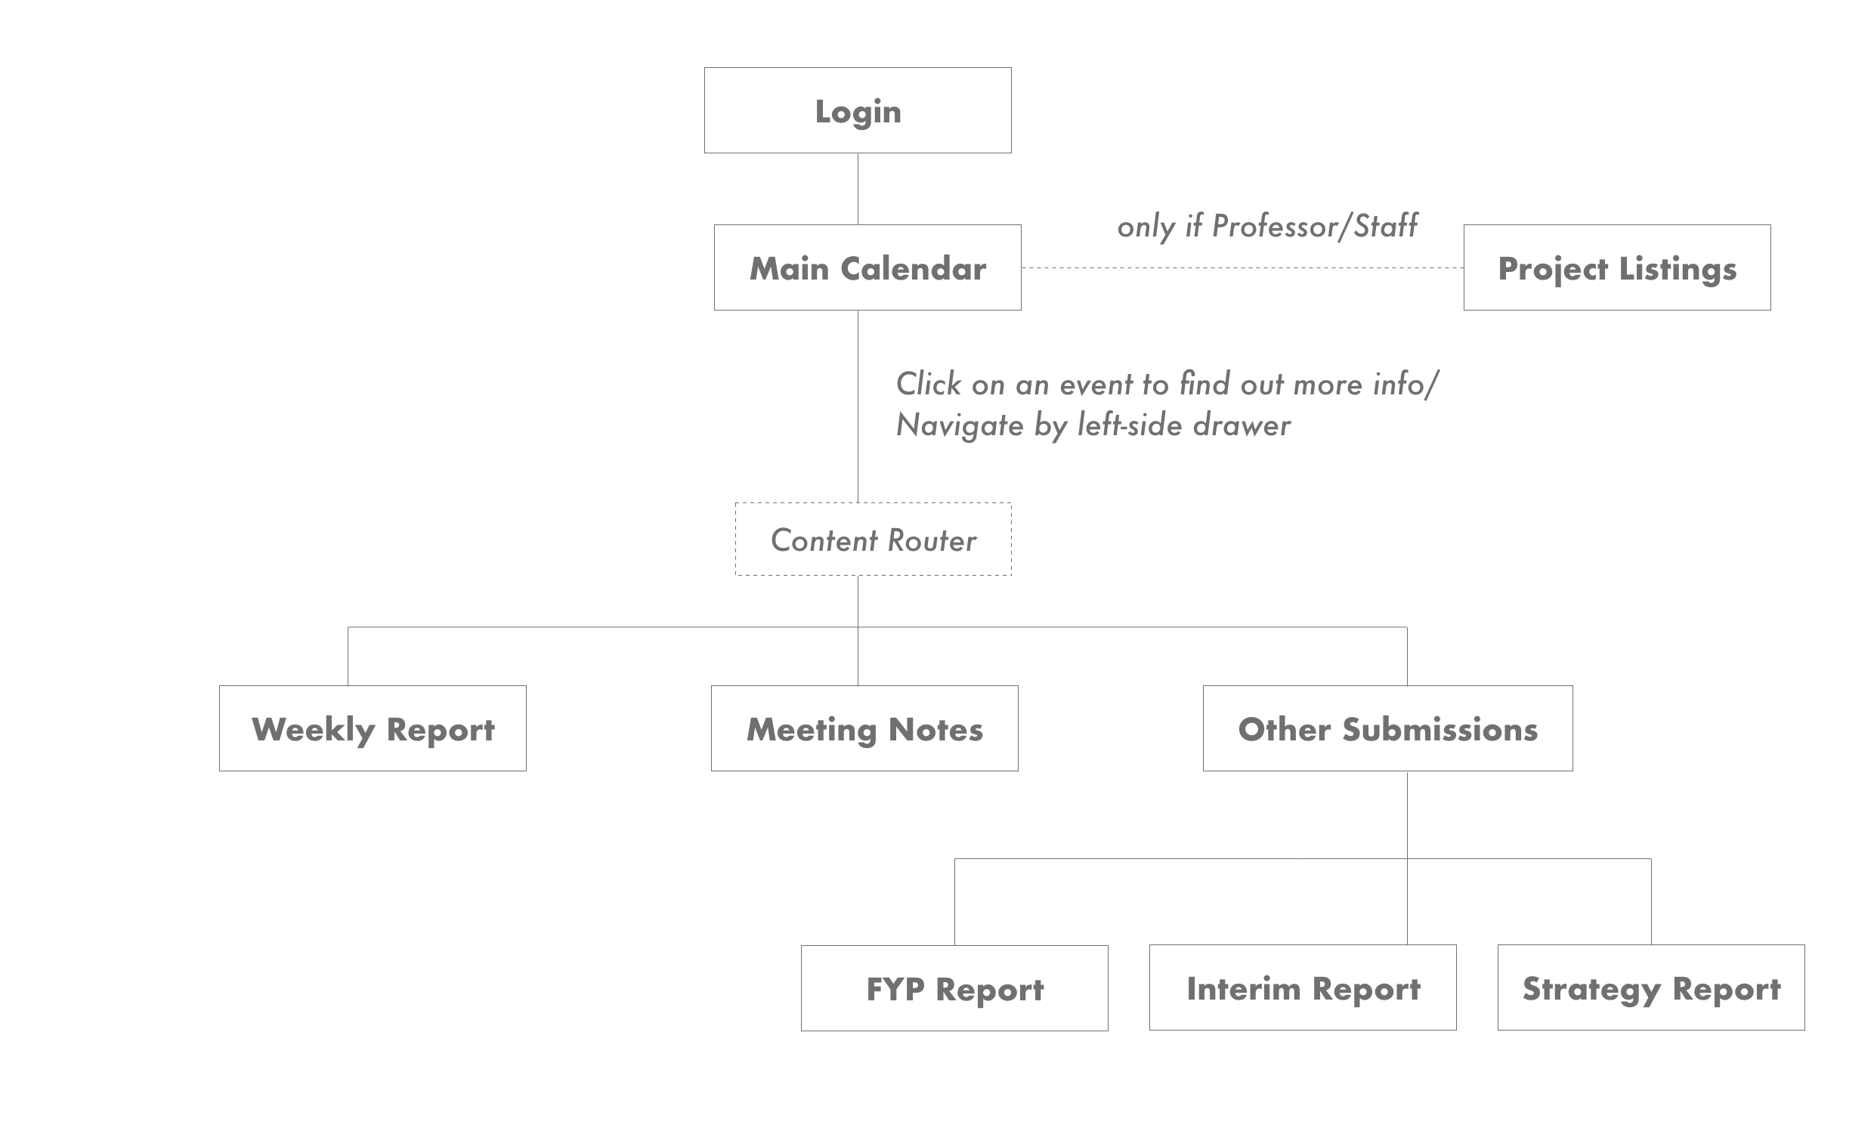

Figure 3: Page layout of platform

### 3.1.5 Determining the routing in the application

Now that we have the page layout, we need to consider the routing required in this entire project. Making use of React Router, we will need different routes for different pages, based on the user type (student or supervisor).

The basic routes are placed inside App.js, whereas SpecialRoutes.js contains the conditionals required to access these routes.

For example, a student will have access to:

1. Their own calendars: *path =* “/*student/calendar”*
2. Their own report views: *path = “/:userID/content”*

A supervisor has access to:

1. Their own calendars: *path = “/staff/calendar”*
2. Their student’s report views: *path = “/:studentUserID/content”*
3. A project listing view that is protected: *path = “/staff/projectlistings”*

Taking note that only students the supervisor is overseeing, can access the student’s report views.

As seen in the snippet below, this is how the various paths are categorized and the conditionals can be applied to the wrapper of multiple paths.

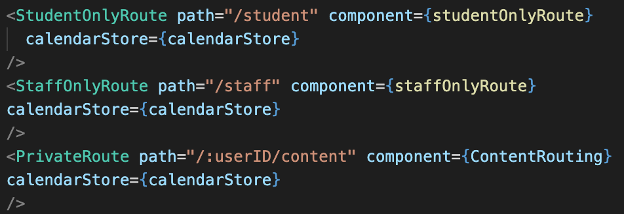

Figure 4: Categorizing Routes with Conditionals

## 3.2 Design Process

After deciding on the design requirements, the process to development is as follows: (1) Create low-fidelity designs, (2) Move to high-fidelity designs, (3) Break down the component and (4) Begin the development cycle.

### 3.2.1 Low-Fidelity Design

Low-fidelity (low-fi) prototyping is a fast and simple way to translate concepts into tangible ones. They can be done as simply on a piece of paper or on a software as I am, Adobe XD.

#### 3.2.1.1 Calendar View

The low-fi design for the main calendar page revolved around a main header/navigation at the top, along with a calendar at the bottom that did not stretch to the sides.

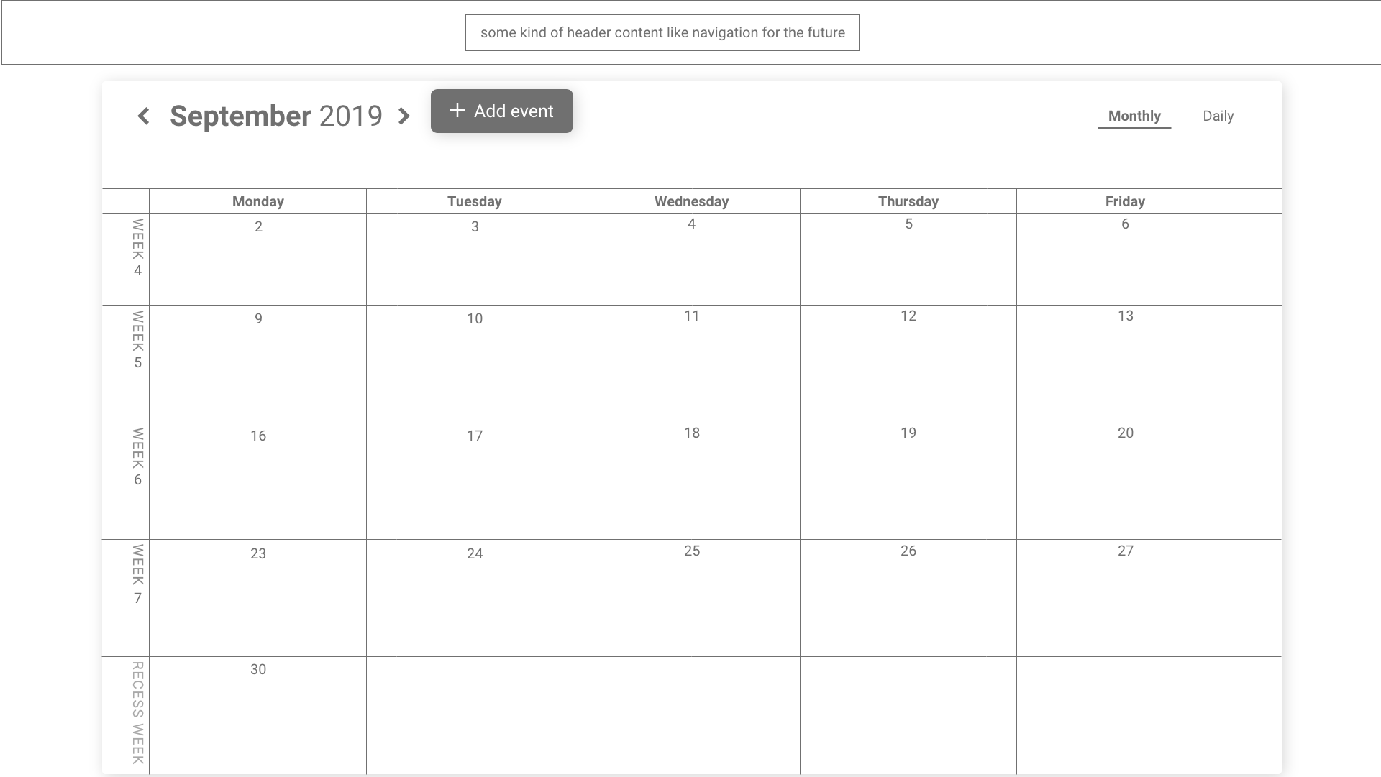

Figure 5: Low-Fi Main Calendar Design

It is compact and kept within its own paper with the necessary views like week number and from Monday to Friday.

#### 3.2.1.2 Reports View

##### 3.2.1.2.1 Weekly Report and Meeting Notes View

The Weekly Report view would look similar to the Meeting Notes view in terms of having a region for students to input information, and another region for comments or attachments to take place.

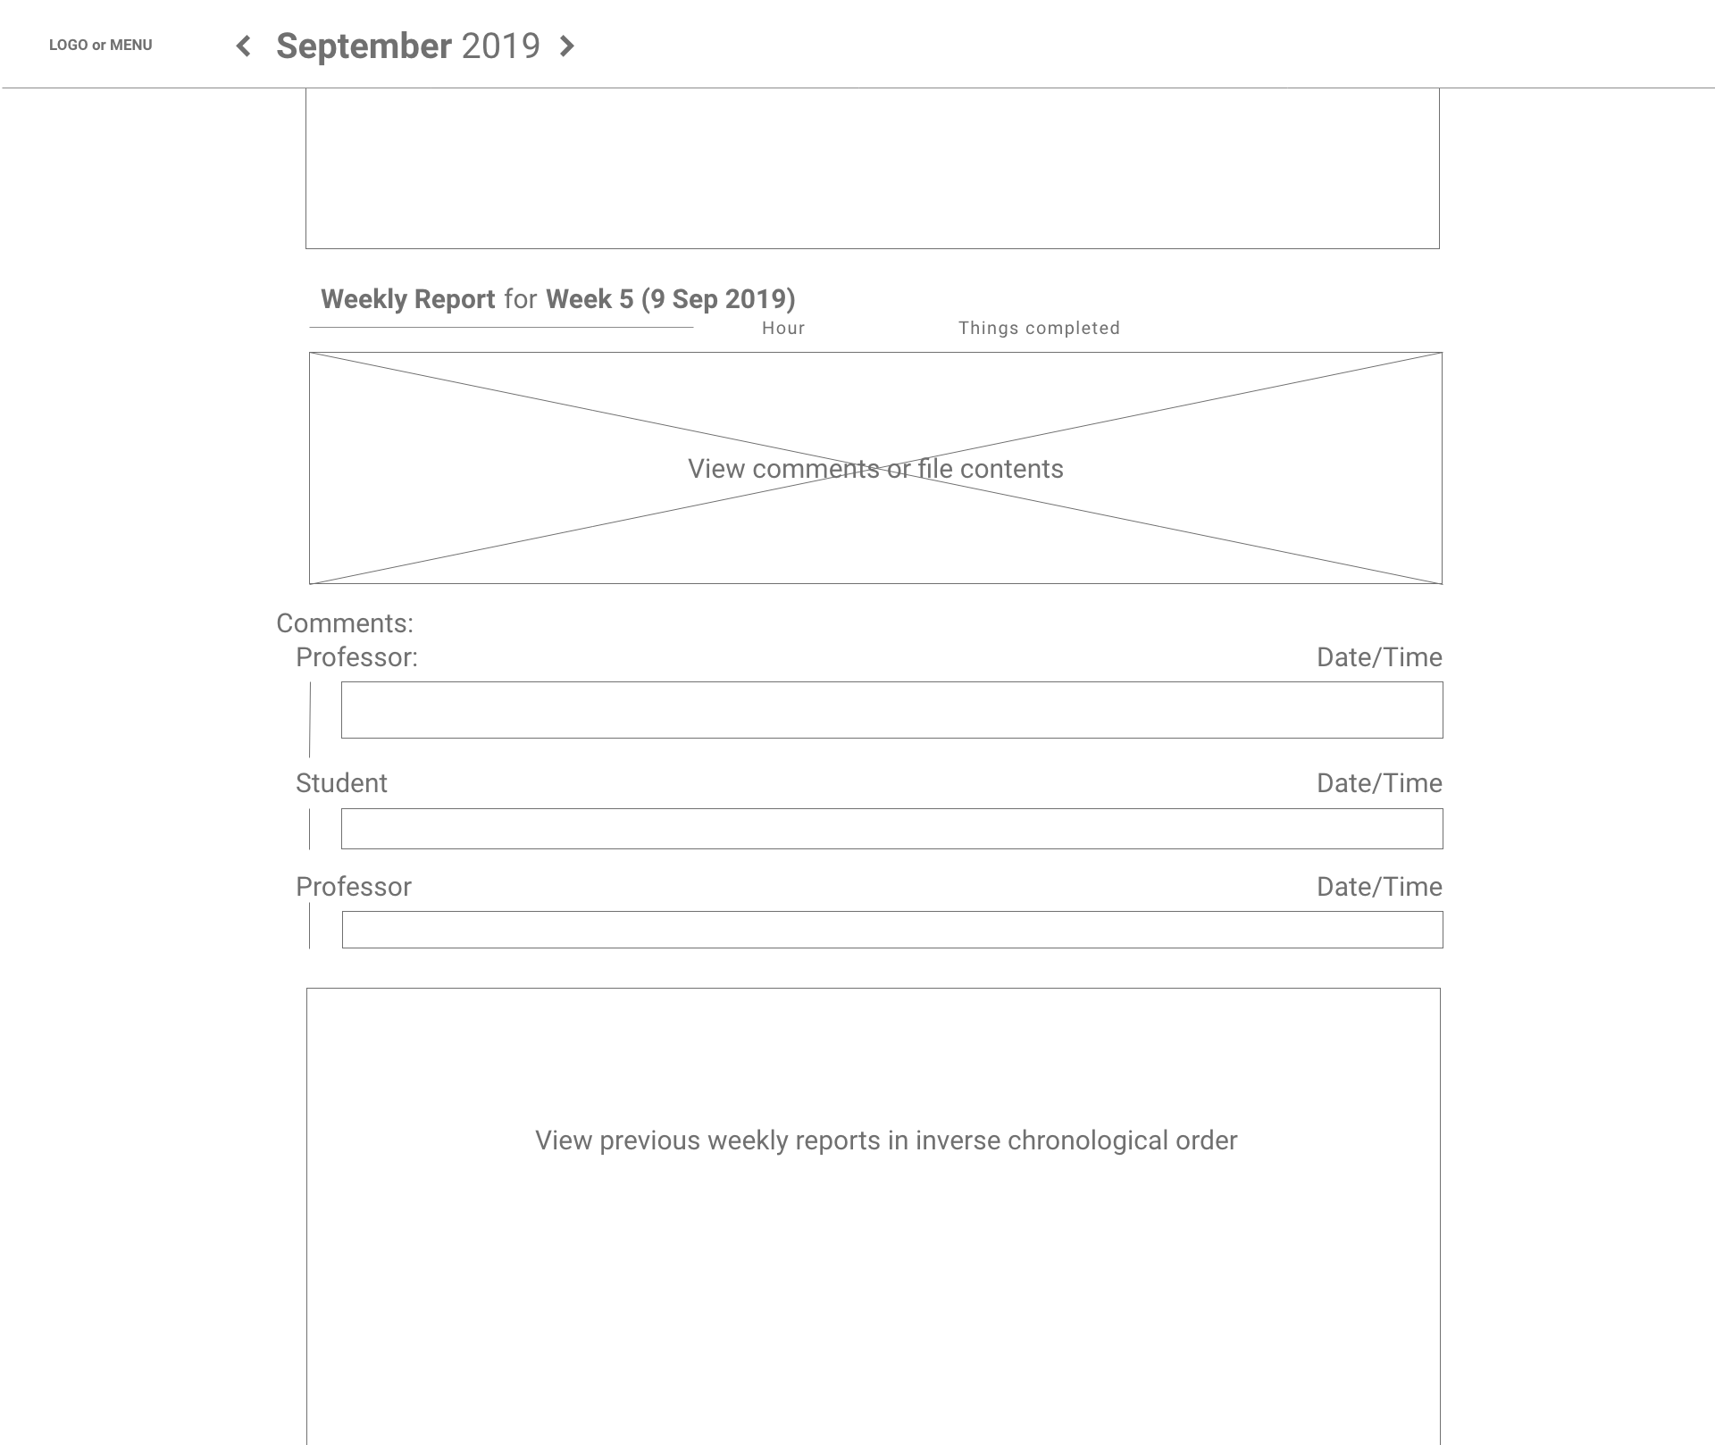

Figure 6: Low-Fi Weekly Report Design Version 1

The comments/attachments will be placed below the report details so that each report is the focal point of the week. These are sorted in inverse chronological order so that the most recent week is at the top, and the later weeks at the bottom.

After further discussion with my supervisor, we decided it might be better to have the comment/attachment section right beside the content so that they can be viewed simultaneously.

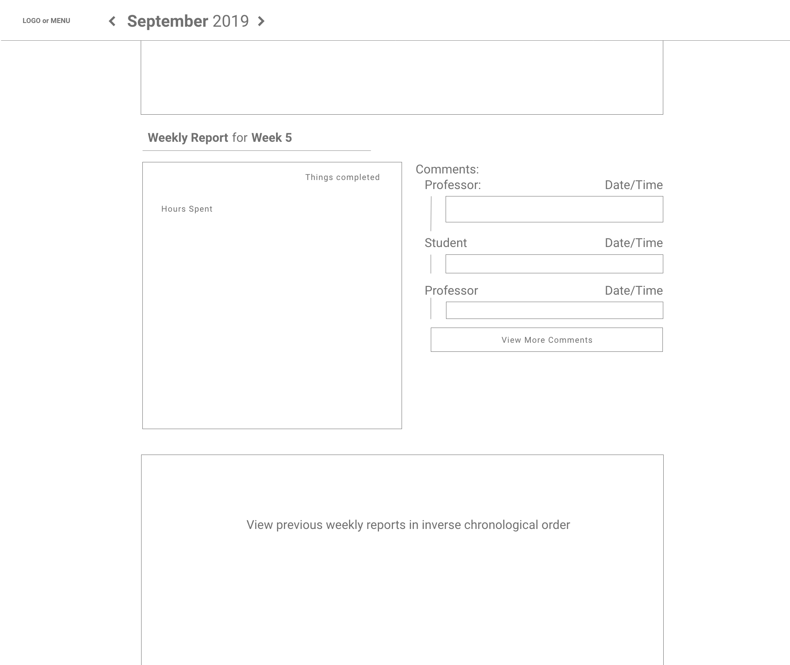

Figure 7: Low-Fi Weekly Report Version 2

With further explorations, I decided to go with the expansion panel from Material-UI.

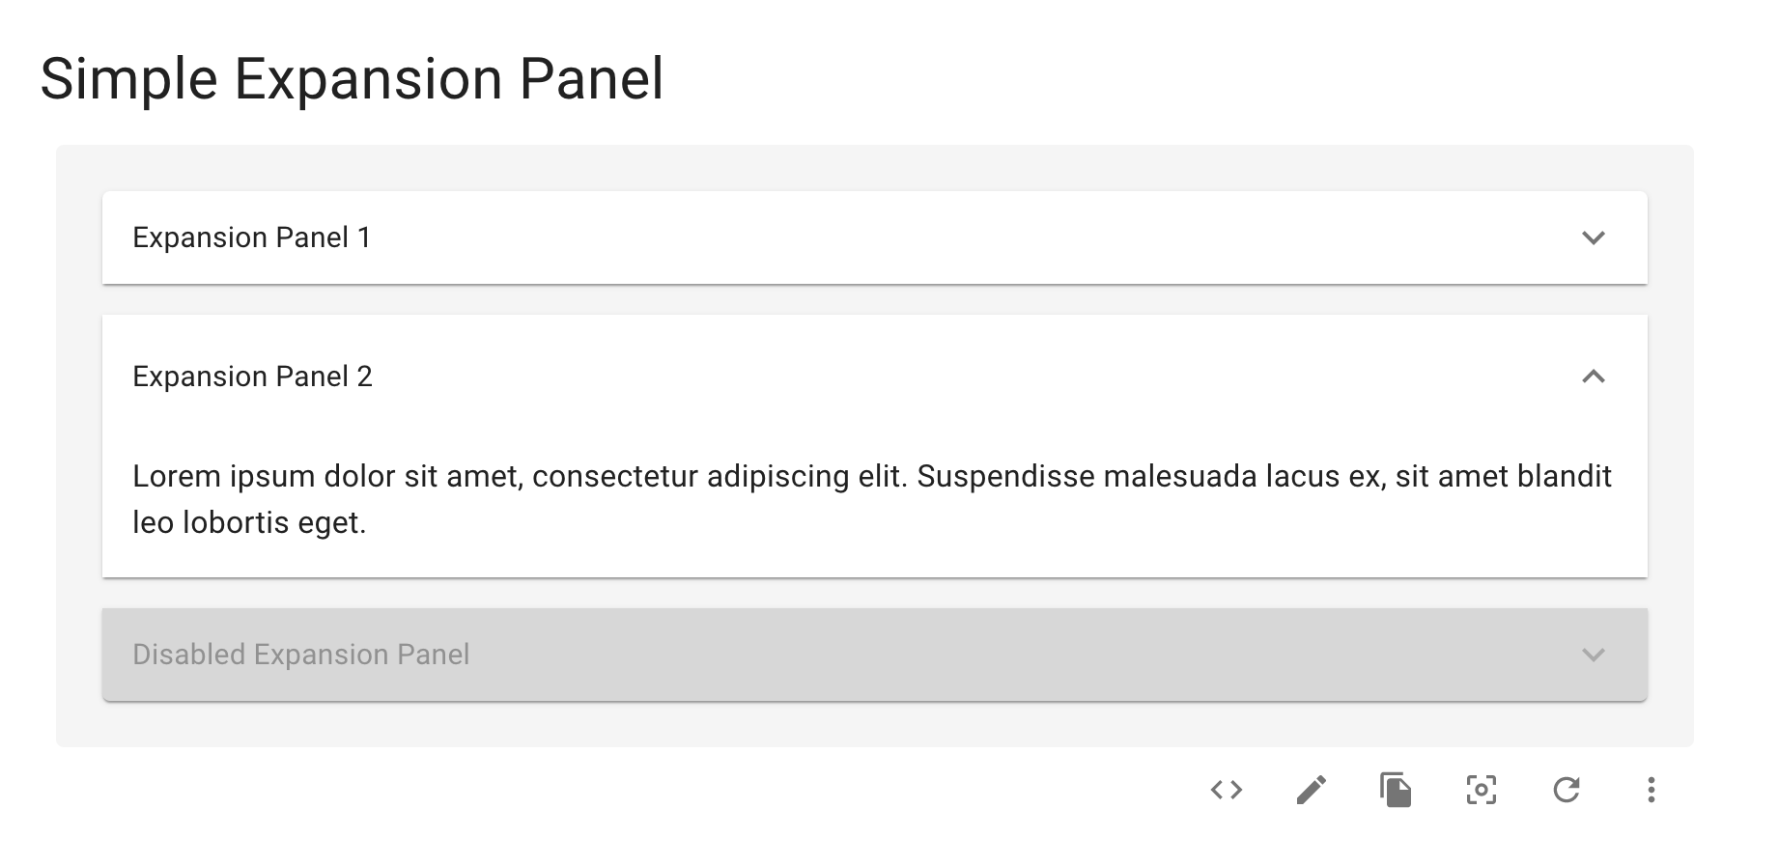

It is chosen for 2 reasons:

1. Easy grouping of data upon first glance. This way, anyone can immediately compartmentalize the content based on the week.
2. Condensation of information if certain weeks get too long, or if the user wants to hide certain weeks.

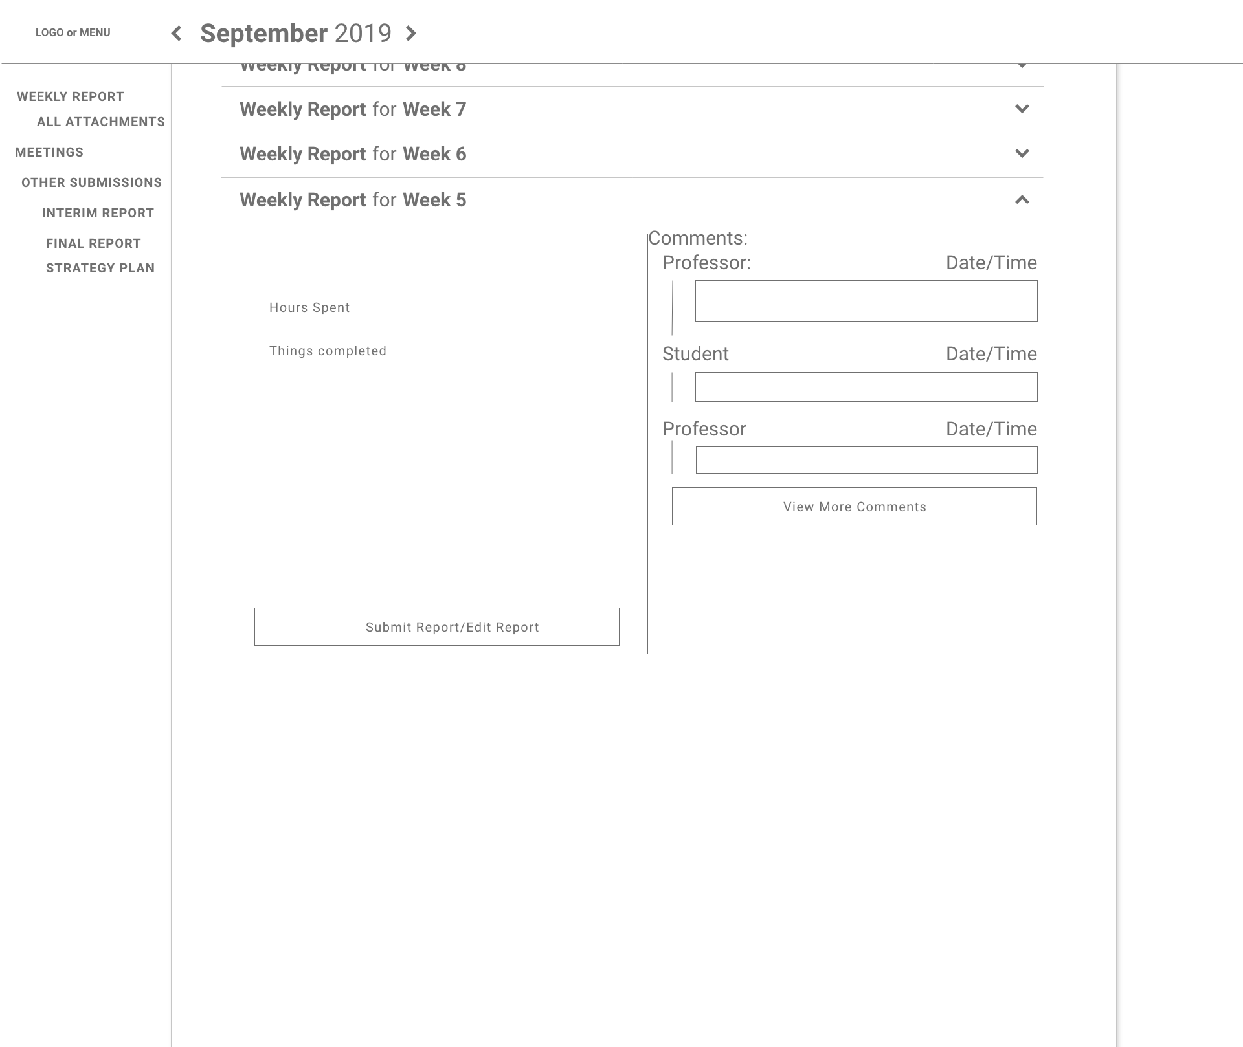

Figure 8: Low-Fi Weekly Report with Expansion Panels

##### 3.2.1.2.2 Other Submissions View

In this section, the Interim Report, Final Report and Strategy Plan submissions are grouped here. As the main functionality is to upload and view the documents, an initial design is as follows.

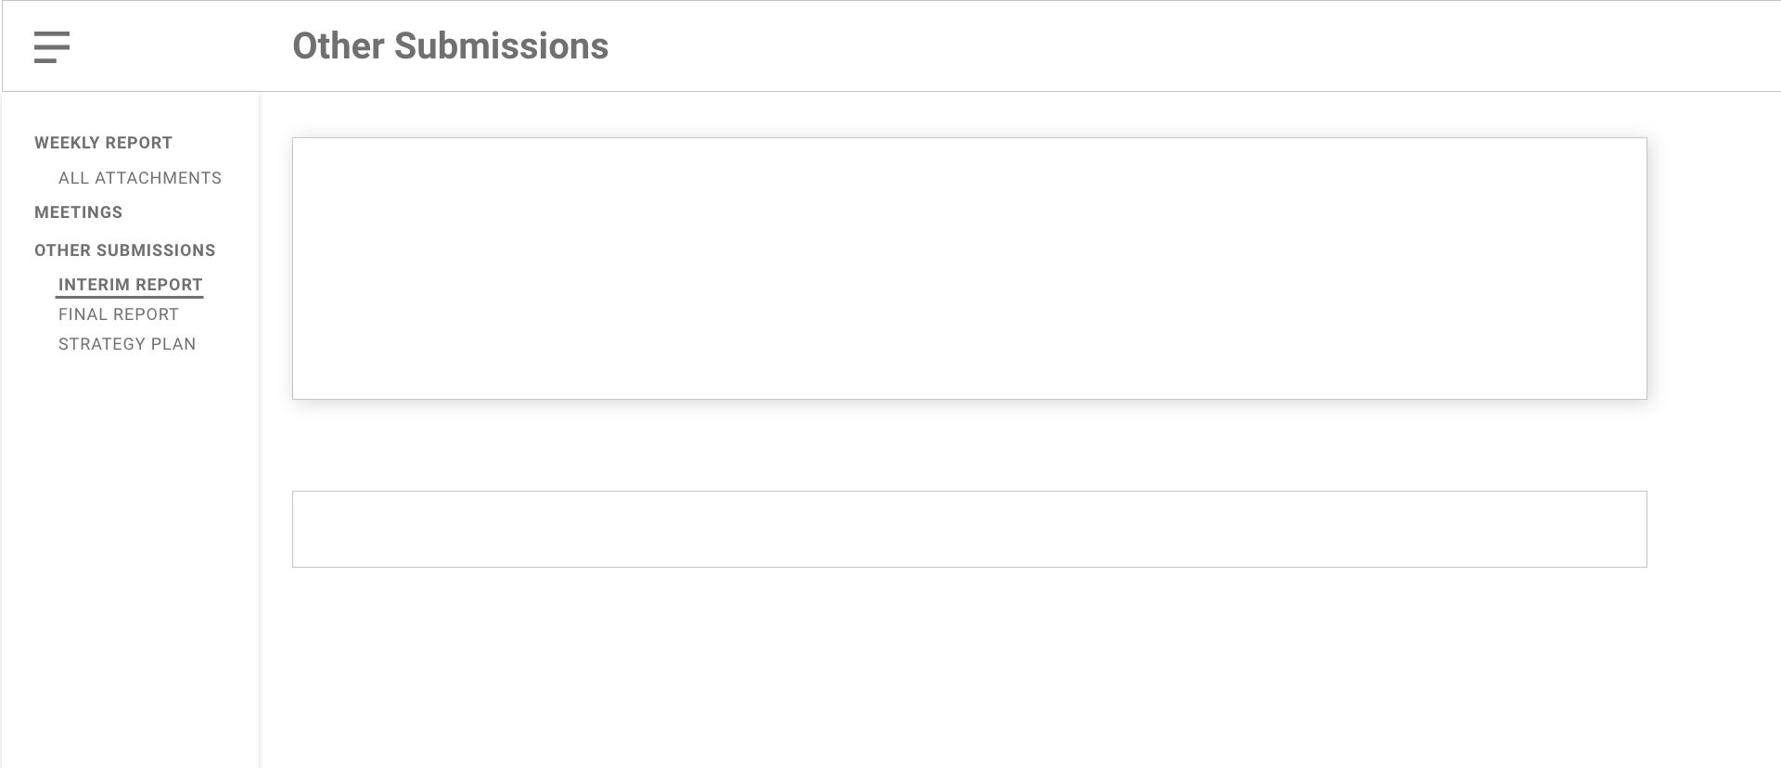

Figure 9: Low-Fi Other Submissions Design

Further exploration into these 3 views will be delved into in the high-fidelity design.

### 3.2.2 High-Fidelity Design

High-fidelity (hi-fi) designs are functional and interactive. They look much closer to the final product but of course, changes can still occur in the development cycle.

#### 3.2.2.1 Sign-In View

A simple sign-in page will be created to handle user authentication before accessing the platform.

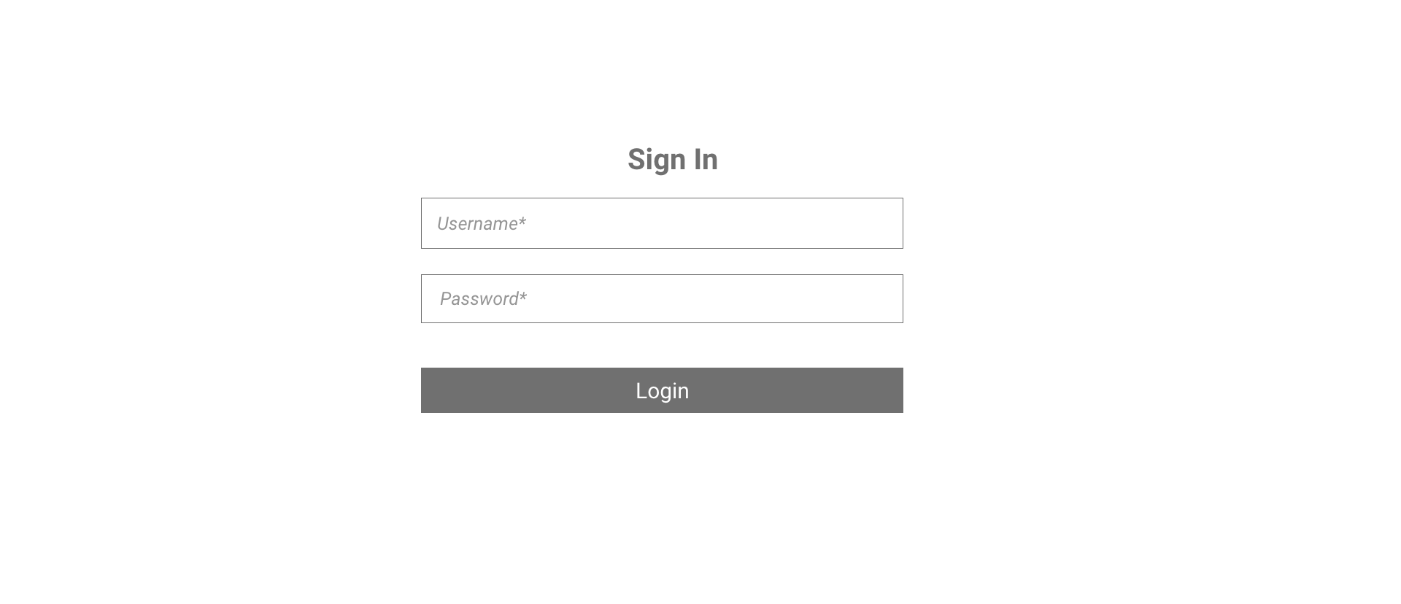

Figure 10: Hi-Fi Sign-In Design

There will also be event handlers in the case of wrong credentials being entered into the form. An example of it will be shown in the later chapters. We want the main focus and purpose of the sign-in page to be the form itself, which is why the form is the most dominant aspect.

#### 3.2.2.2 Calendar View

In the hi-fi for the main calendar, stronger influences from Google Calendar and Outlook Calendar began to form.

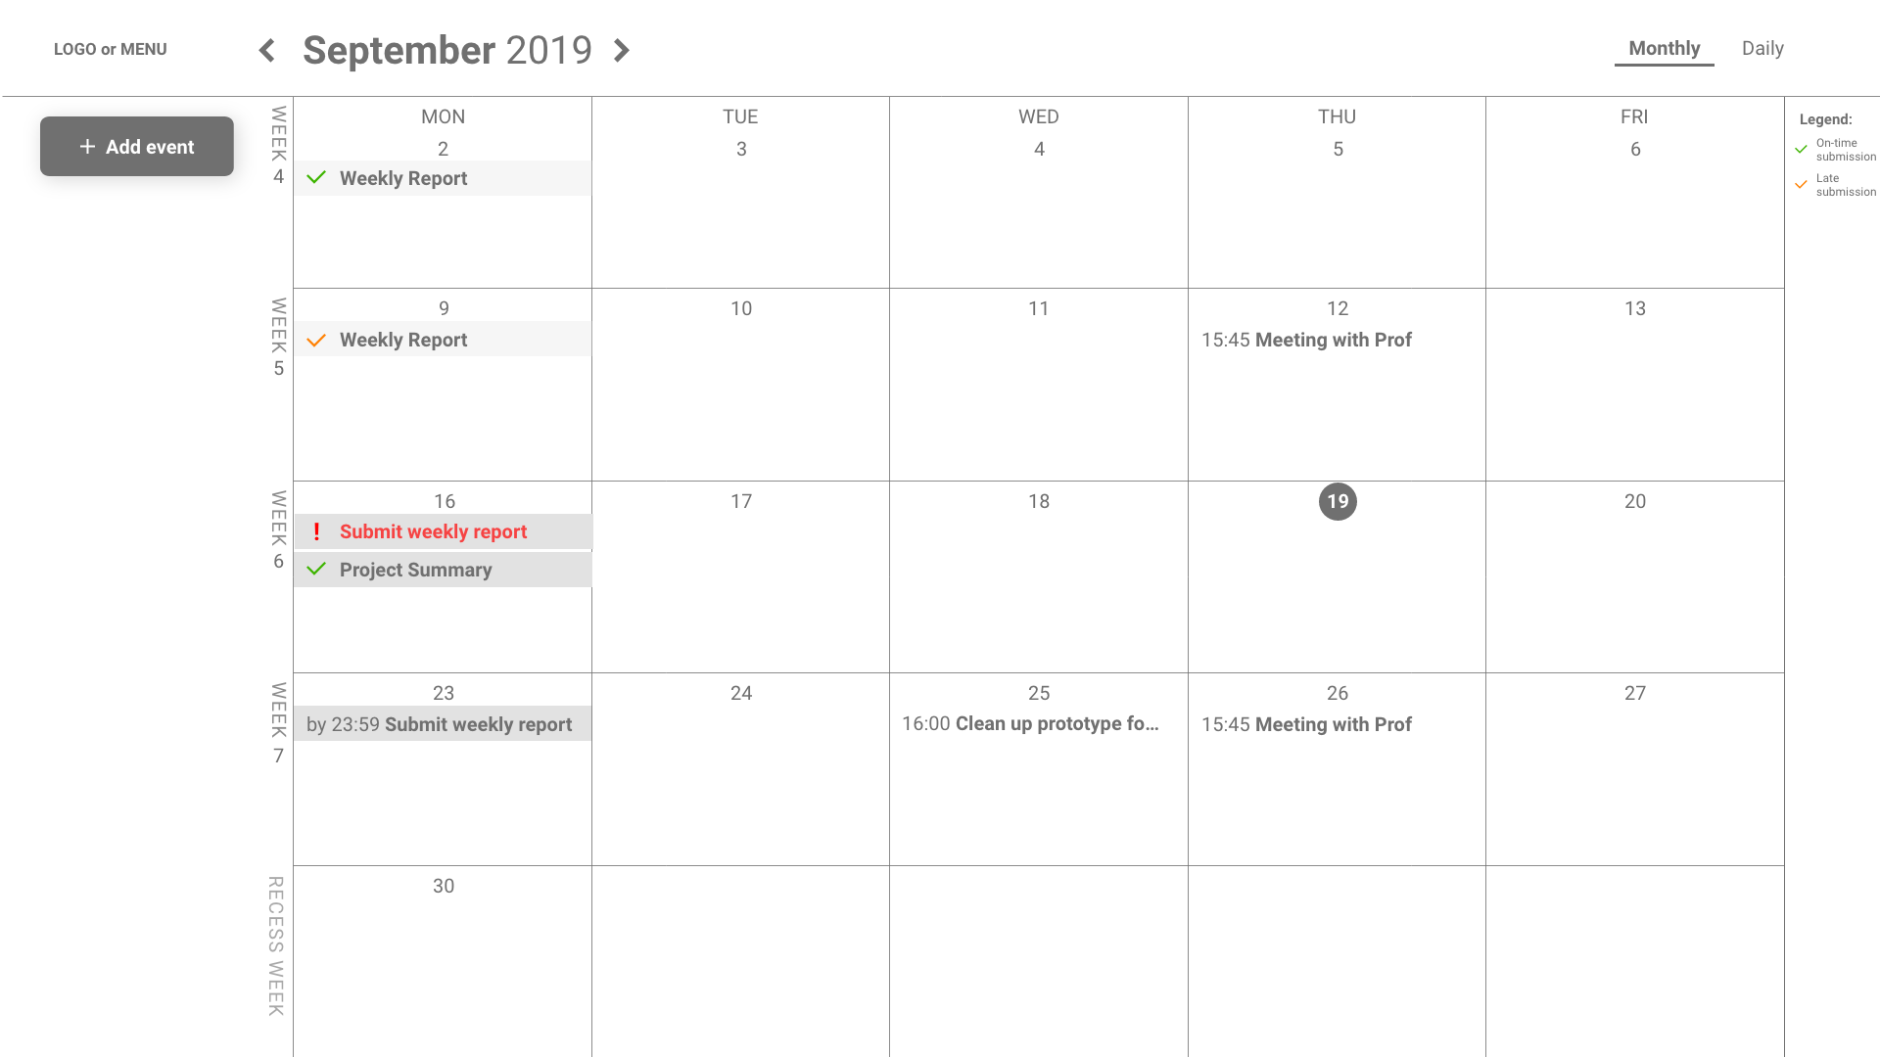

Figure 11: Hi-Fi Main Calendar Design

Here, the calendar takes full width with a change in the positioning of the “Add Event” button along with the styling of an event.

In an attempt to display different states with just colors and symbols, these are what it means:

1. Completed: A green tick
2. Late: An orange tick
3. Late Submission: A red exclamation mark
4. Pending: A timing is shown beside (e.g. “by 23:59”)

The symbols are kept close to the event titles as proximity shows their relationship. Also, having repeated, similar looking events helps the user to see the rhythm in their positioning and quickly relate that they’re all part of the calendar, as an event.

Since this is still a hi-fi design, slight changes will be made to cater to easier understanding of the symbols such as through a summarized version of the event and simplifying the symbols.

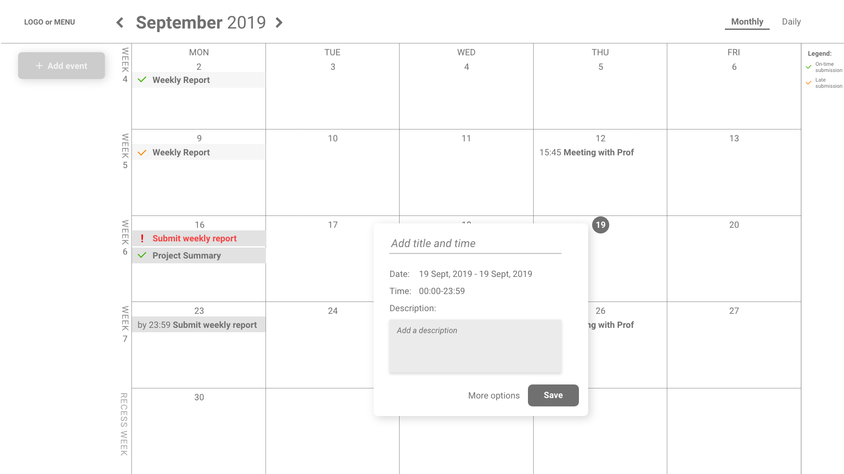

Figure 12: Hi-Fi Main Calendar Add Event Design

In order to add events, a pop-up will appear, inviting users to include the title, time, date and any description needed. There is a “More options” button to allow for other sorting or repeating functions.

However, after much considerations, this design will be changed to make it easier for the user to categorize without missing any information and it will be shown in Chapter 4 during the development process.

#### 3.2.2.3 Reports View

##### 3.2.2.3.1 Weekly Report View

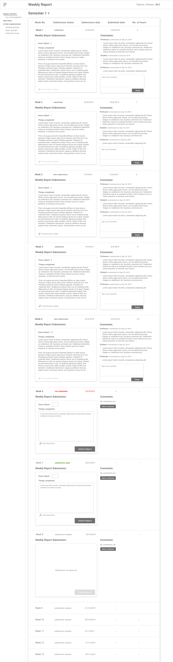

Figure 13: Hi-Fi Weekly Report Design

In this view, there is a comment section on the right and the content on the left. At the top right corner are the total number of hours the student has spent on the project, based on their input. The 2 sections are kept close together to show proximity and relation of the objects but there is still balance between the 2 main content sections, where they complement each other instead of dominating either section.

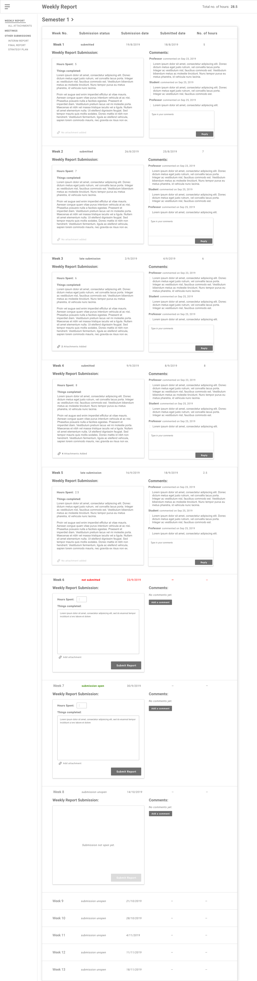

Figure 14: Hi-Fi Weekly Report Design – w/ Content vs w/o

There are 2 main versions of this view – one without content and one with content. The comment section will be open and able for anyone to comment regardless of whether there is content or not.

##### 3.2.2.3.2 Meeting Notes View

In the meeting notes, there is greater emphasis on the attachments, and it does not require a comment section since it is mainly for the students to keep track of meetings and for professors to read through if they’d like to.

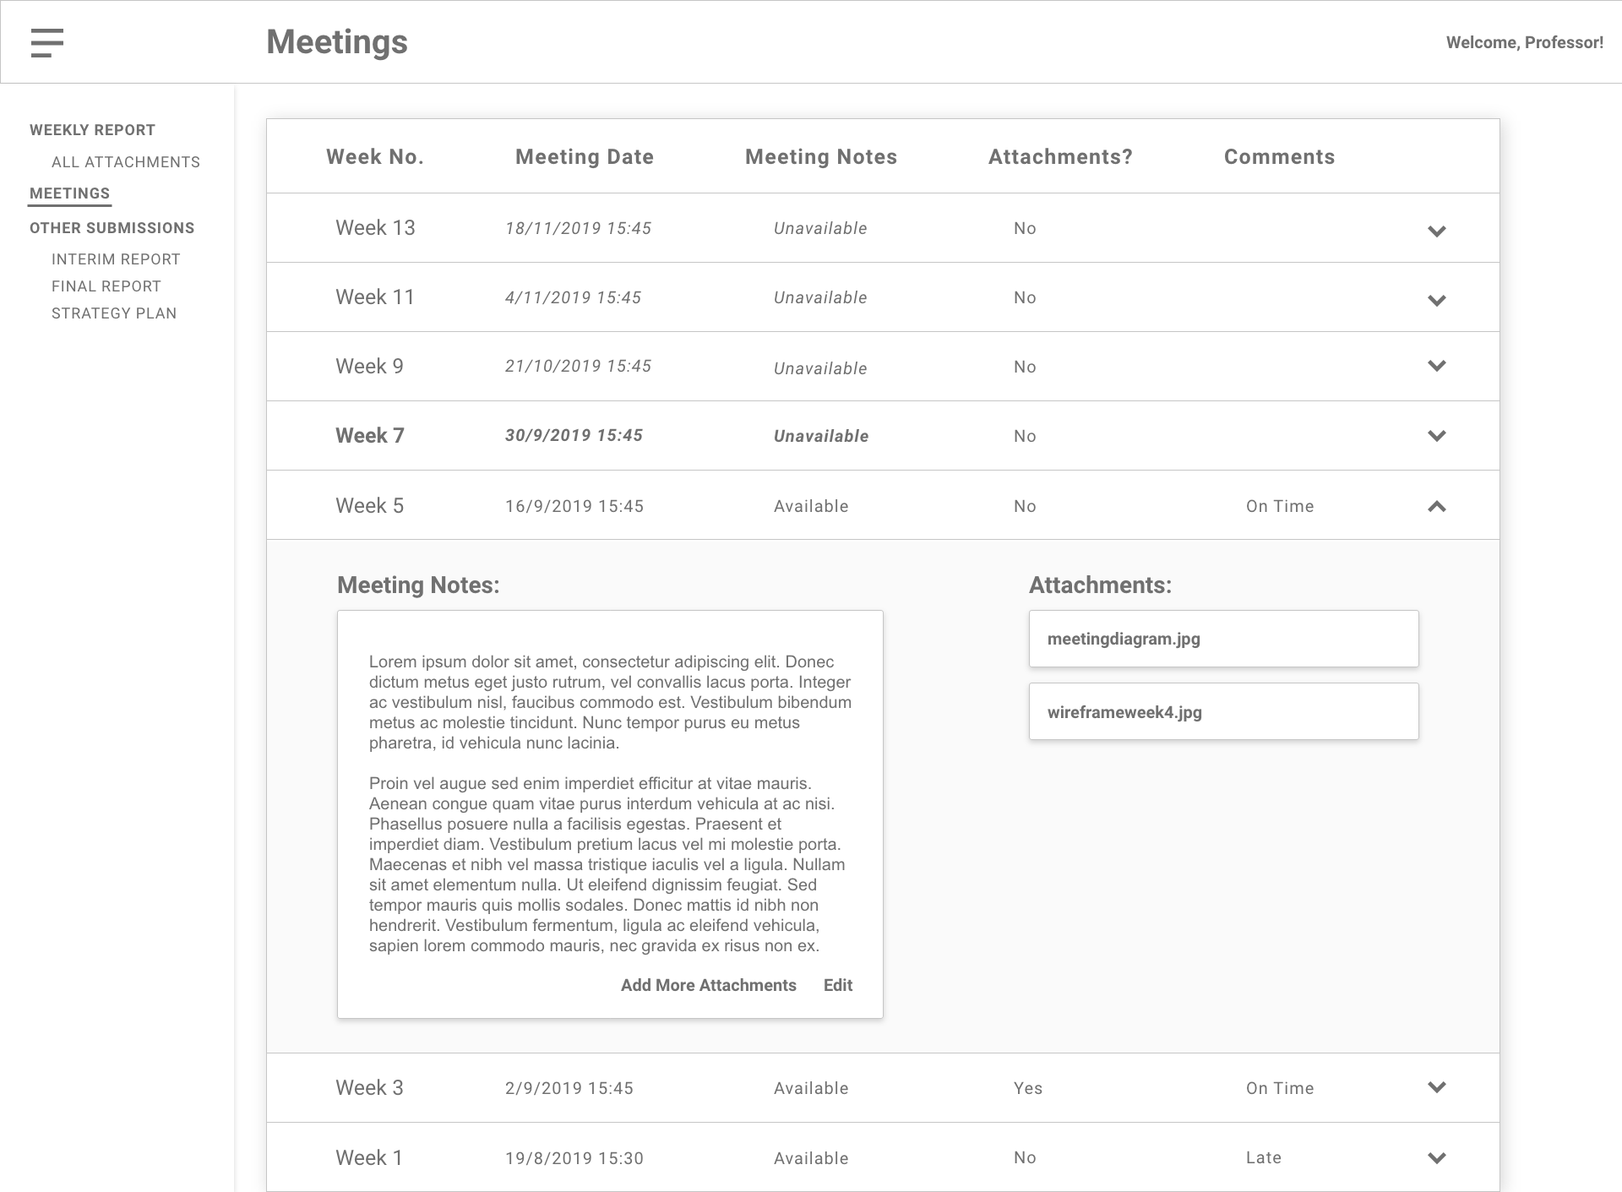

Figure 15: Hi-Fi Meeting Notes Design w/ Attachments

These attachments could range from an image to a word document of the meeting. In the event that no attachments are added, it’ll look as such:

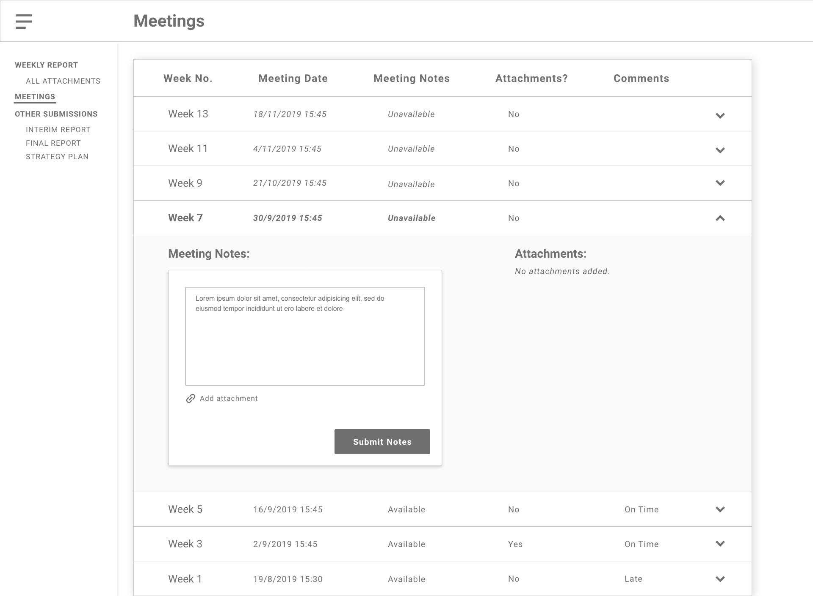

Figure 16: Hi-Fi Meeting Notes Design w/o Attachments

And the condensed view of the meetings page looks like the following:

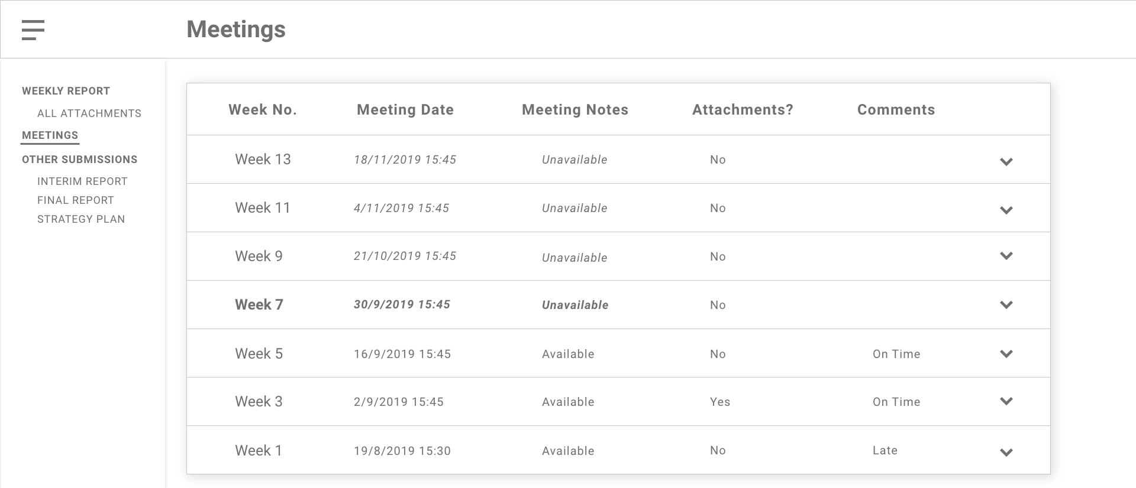

Figure 17: Hi-Fi Meeting Notes Condensed Design

Certain attributes in the view such as the “Comments” became redundant because as long as the meeting notes are submitted, it suggests that the student arrived for the meeting and it would be an extra step for already busy professors to have to reflect whether or not a student was “On Time” or “Late”. Thus, it is removed in the next iteration.

##### 3.2.2.3.3 Other Submissions View

For the other submissions, as the interim report, final report and strategy plan has the same objective: for the students to upload their report (multiple times if needed) and the professor can comment on the uploads.

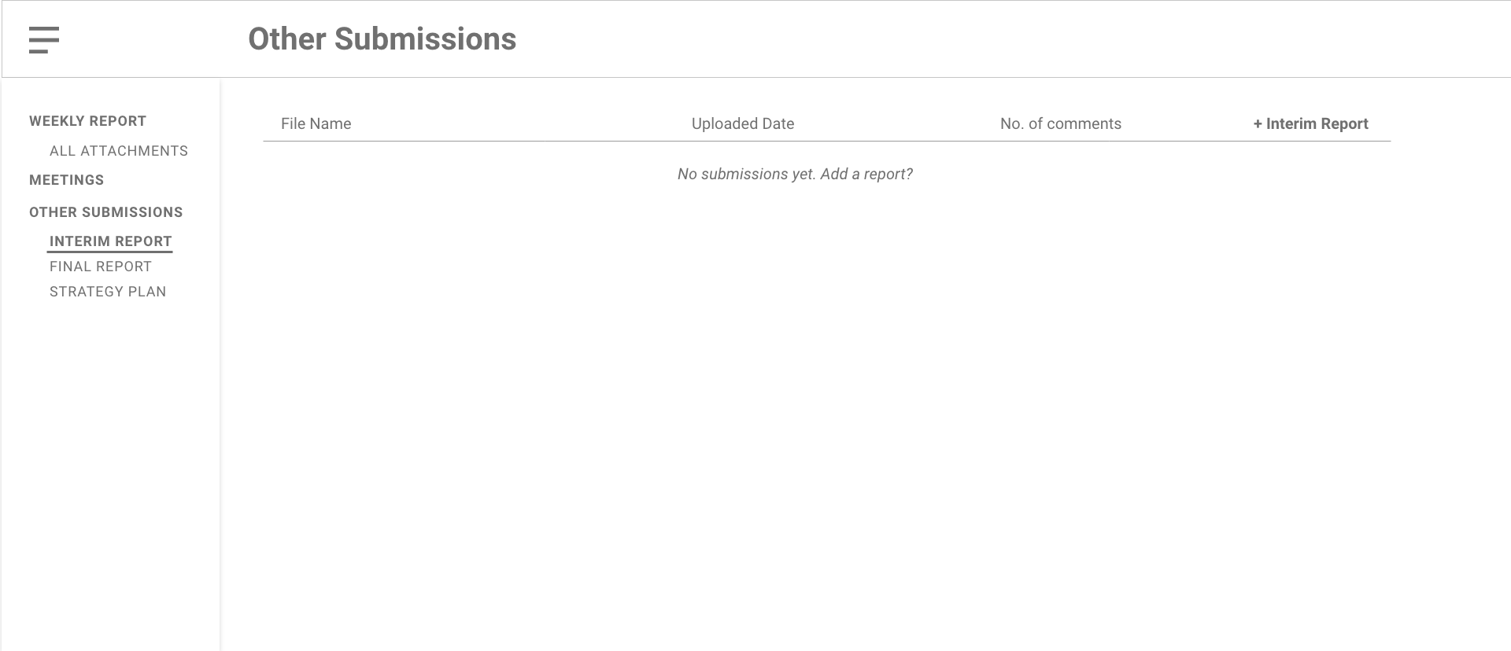

Figure 18: Hi-Fi Other Submissions w/o Submissions Design

I decided to go a much simpler route by only making the sole focus on the documents and the comment section, which can be viewed by clicking on the “x comments” under “No. of comments”.

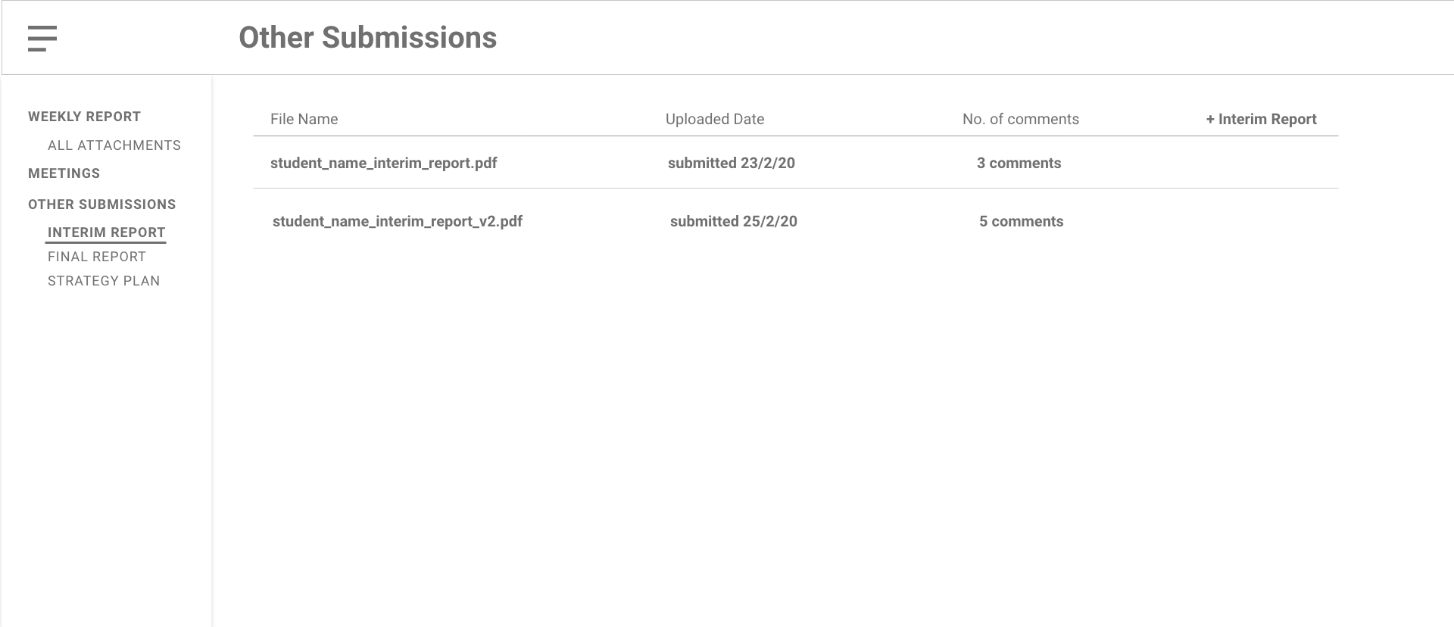

Figure 19: Hi-Fi Other Submissions w/ Submissions Design

In this hi-fi, the idea here is to have multiple comments for each document. But changes will be made during the development cycle and will be delved into further at a later time.

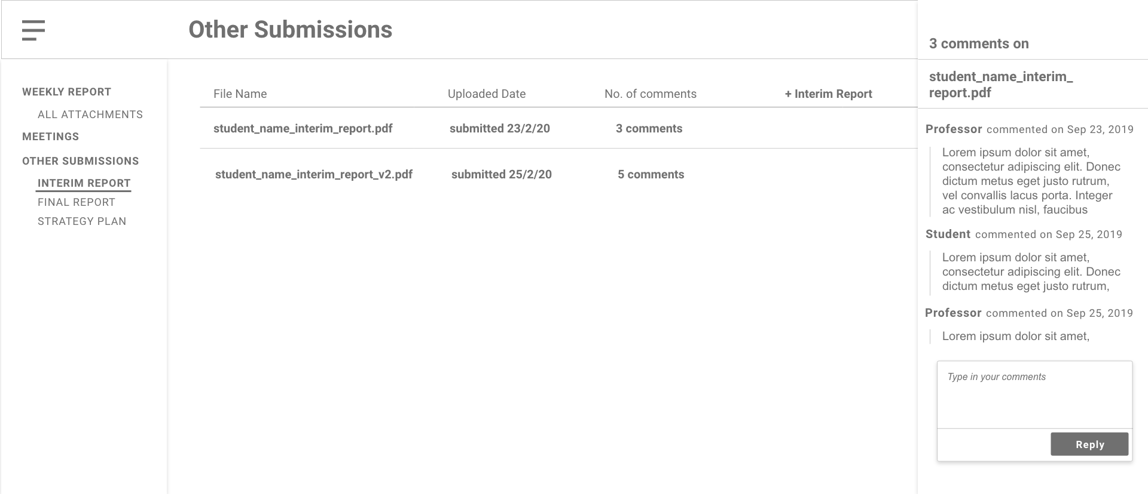

Figure 20: Hi-Fi Other Submissions w/ Comment Section Design

### 3.2.3 Component Design

Components are the building blocks for any React app – it can accept inputs (known as props) to return a React element that displays the user interface. By building in components, not only is it easier to breakdown an entire project, but we can also make use of reusable components and keep our codes clean and simple.

Before we begin any development, as a front-end developer, we have to look at the designs and break them down into components.

Here, I will be using the final product and work backwards to show the components needed.

#### 3.2.3.1 Sign-In View

A basic sign-in form requiring the credentials and a sign-in button along with a sign-in logo to let the user know what page they’re on.



Figure 21: Sign-In Component Breakdown

#### 3.2.3.2 Calendar View

The calendar view simply consists of the main calendar, individual events in it, a top navigation to navigate between months and views (Month or Weekly view) and a left-side column that contains a drawer, an “Add Event” and filtering of projects (which is only accessible for Professors/Staff).

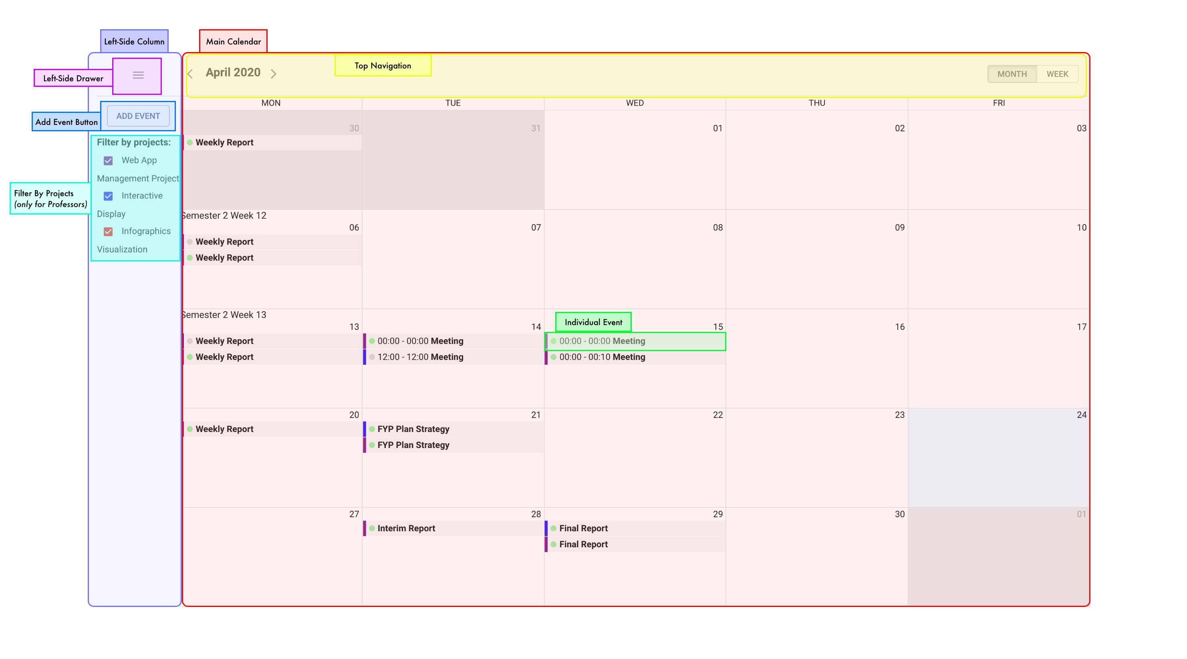

Figure 22: Main Calendar Component Breakdown

#### 3.2.3.3 Reports View

Amongst the reports, they tend to have multiple reusable components – if reused, they will have the same name applied in their boxes. In order to navigate between views, a common persistent drawer from Material-UI is used on the left-hand side. They all have a top navigation which uses the AppBar from Material-UI to indicate to the user which page they’re on.

##### 3.2.3.3.1 Weekly Report View

The main crux of the weekly report view, like the meeting notes view, has 2 sections: 1 for details, another for a comment box or attachments. They both use expansion panels and have a header for the panel

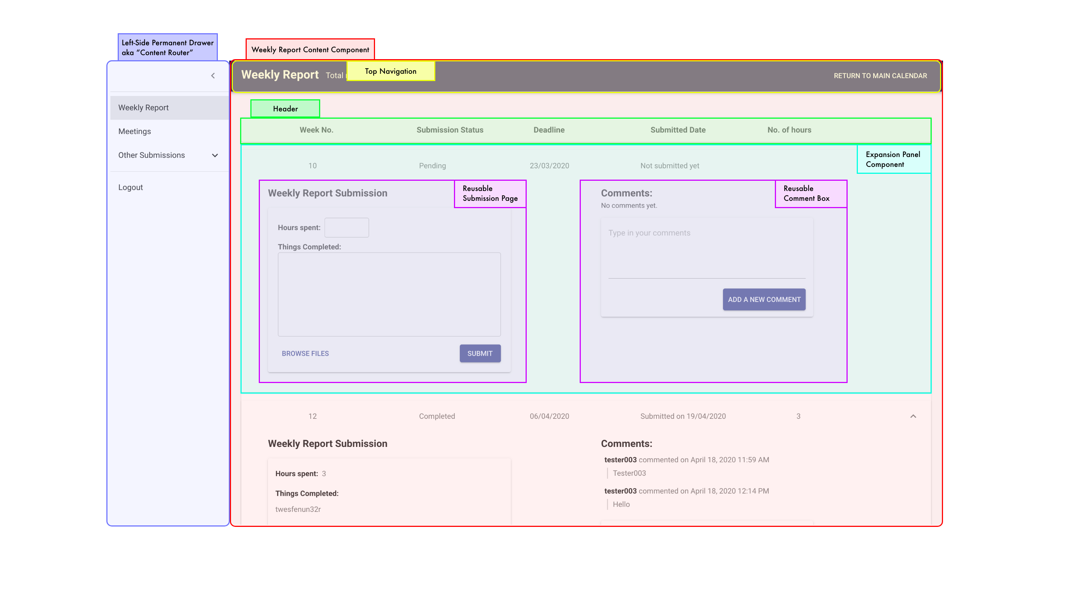

Figure 23: Weekly Report Component Breakdown

They can add and display attachments as required.

##### 3.2.3.3.2 Meeting Notes View

For the meeting notes, the attachments are to the right instead of on the left as seen in the weekly report view.

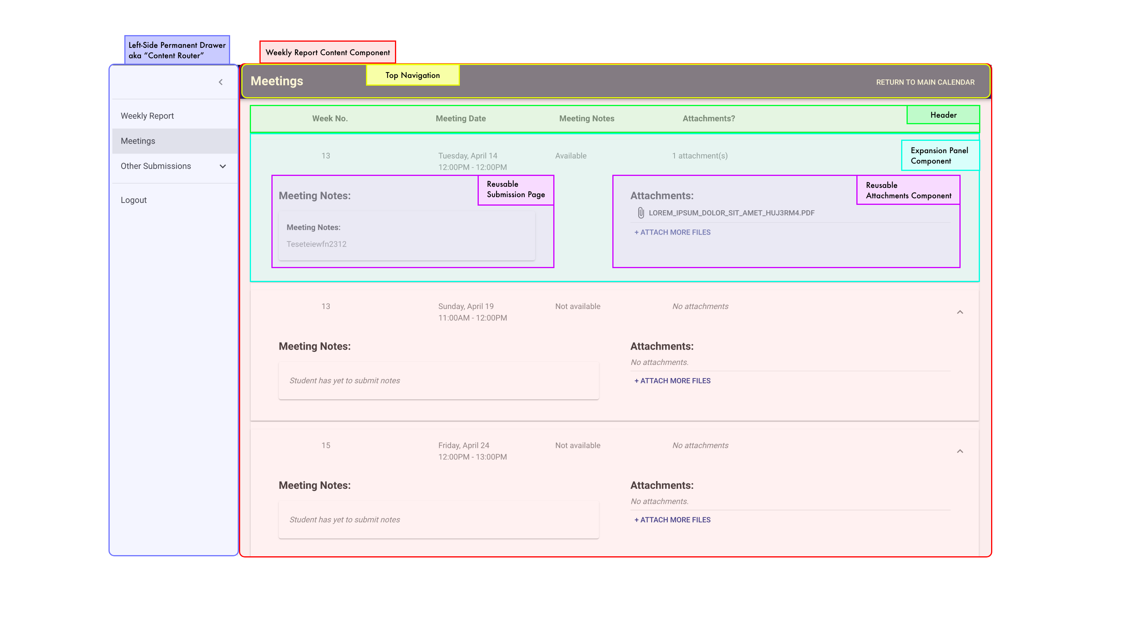

Figure 24: Meeting Notes Component Breakdown

##### 3.2.3.3.3 Other Submission View

Finally, on the left-side drawer, you can see that the 3 sections – Strategy Plan, Interim Report and Final Report – are nested under “Other Submissions”.

They will have similar layouts, focusing on the documents and the comment section (which is a reusable drawer on the right side).

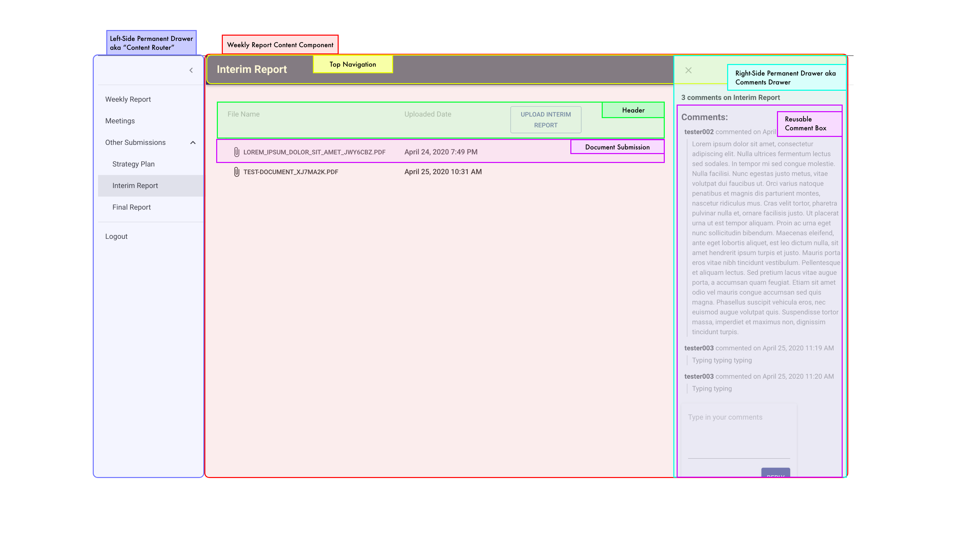

Figure 25: Other Submissions Component Breakdown

### 3.2.4 Design Decisions

#### 3.2.4.1 Theme & Color Palette

In creating the primary and secondary color palettes, we need to consider the “branding” of this project. I wanted to project a sense of stability, calm and trust in the platform. Which is why the main palette consists of blues, namely the palette you see in Figure 26. It has a mixture of a dark, light and main blue [17].

Text colors are kept simple at black and white as they play well as a contrasting color and a readable color.

The secondary palette is used for error messages; thus, its palette revolves around reds as it is vibrant and widely known to anyone that it means an error has occurred. Again, with a dark, light and main red.

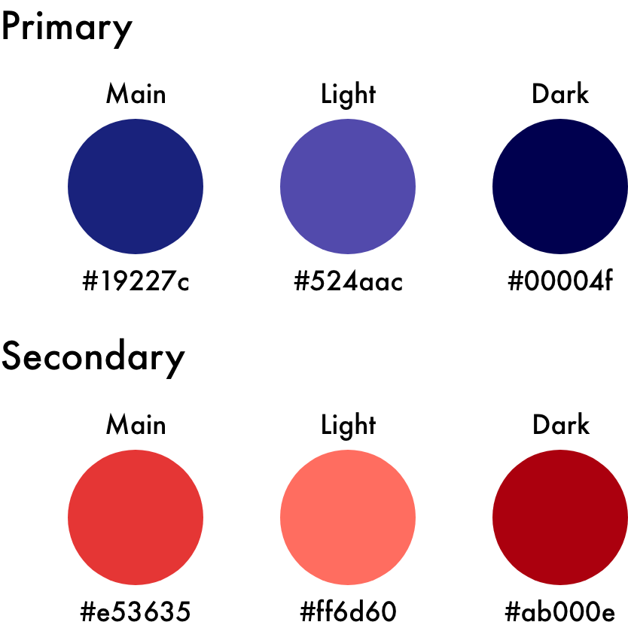

Figure 26: Colour Palette for Platform

#### 3.2.4.2 Typography

When choosing typography, there are a few considerations to go through.

Firstly, it is important that the typeface is legible and works well in different sizes and weights because there will be different types of users on this platform and a lot of reading will be done too. This meant disregarding unreadable, fancy fonts like Vivaldi which can be difficult to read.

Next, going with sans instead of serif typefaces makes it easy to read, even for those with certain visual impairments [18].

And finally, to limit the number of different fonts in the design.

After much deliberation, I decided to work with Roboto because:

1. It has 4 families with multiple weights. This allows me to only use Roboto for my typeface without having to introduce other fonts. Allowing me to play around with the weights without introducing further visual clutter
2. It has a readable shape and has elegant contrast in its strokes to make all body text easy to read
3. Furthermore, it has been developed and embraced by Google, a strong inspiration in terms of my interface design for this platform

# 

# Results and Discussions

To discuss the results, we need to delve into the development process and layout its resulting cases. In the development process, it usually goes like this:

1. Build the components using Material-UI for the base design components, basing them off from the hi-fi.
2. For components that require data from the database, look through the API and understand what links allows for what data to be sent through
3. Make the connections from the database to the client-side using Axios
4. Send the data to the MobX store for use
5. Any components that require certain data will retrieve it from the store instead of calling the API again

Here, I will go through the how the APIs look like (if there are any) and show the final product along with the various detailed functionalities.

## 4.1 Authentication

In order to authenticate the credentials, a simple axios.post is required, along with the URL-ending rest-auth/login/.

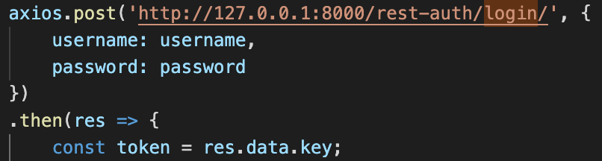

The credentials username and password are sent as an object to the API.

If successful, a key will be returned, and they will be redirected to the calendar page by means of React Router.



Figure 27: Sign-In Component

Otherwise, an error message will be returned.



Figure 28: Sign-In Error Message

## 4.2 Calendar View

### 4.2.1 Deciding on a calendar library

In order to create the calendar view, a few considerations have to take place: Am I building it from scratch or am I relying on a calendar library?

After experimenting with trying to build one from scratch with the help of moment.js, it was decided that there are too many other functionalities to work on, and spending time creating a calendar from scratch was too much work. Afterall, if a calendar library exists, why not make better use of my time to work on other functions?

Thus, I narrowed down my calendar options to: React-Big-Calendar by jquense, FullCalendar by Josh Ruff or ReactCalendar from Syncfusion.

Upon more scrutiny and reading the documentations, these calendar libraries needed to fit 2 criteria:

1. A well-documented library (or in exchange, a library that is constantly updated and the developers will engage with users on any issues faced)
2. Free of charge

The reason for it to be free is so that this platform can have the potential to be open-sourced and will not rely on a paywall in order to access it. It also reduces the burden of having to keep up with payments every month.

Very easily, I ended up with React-Big-Calendar as the basis of my calendar view.

### 4.2.2 Retrieving the data to the client-side

The next issue after importing the library and making tweaks such as

1. Adding the semester and week number based on NTU’s academic schedule
2. Only showing Monday-Friday
3. Certain design changes like the month typography and the way the events look and work

Would be retrieving our own data into the calendar. This required me to access /api/taskComment/ in order to get

1. All the task details (like different *IDs*, *type of task*, *status*, *content* written)
2. *Comments* on the task (in this case, only Meeting Notes do not have comments)
3. *Documents* attached

It is wrapped up in the API as seen below.

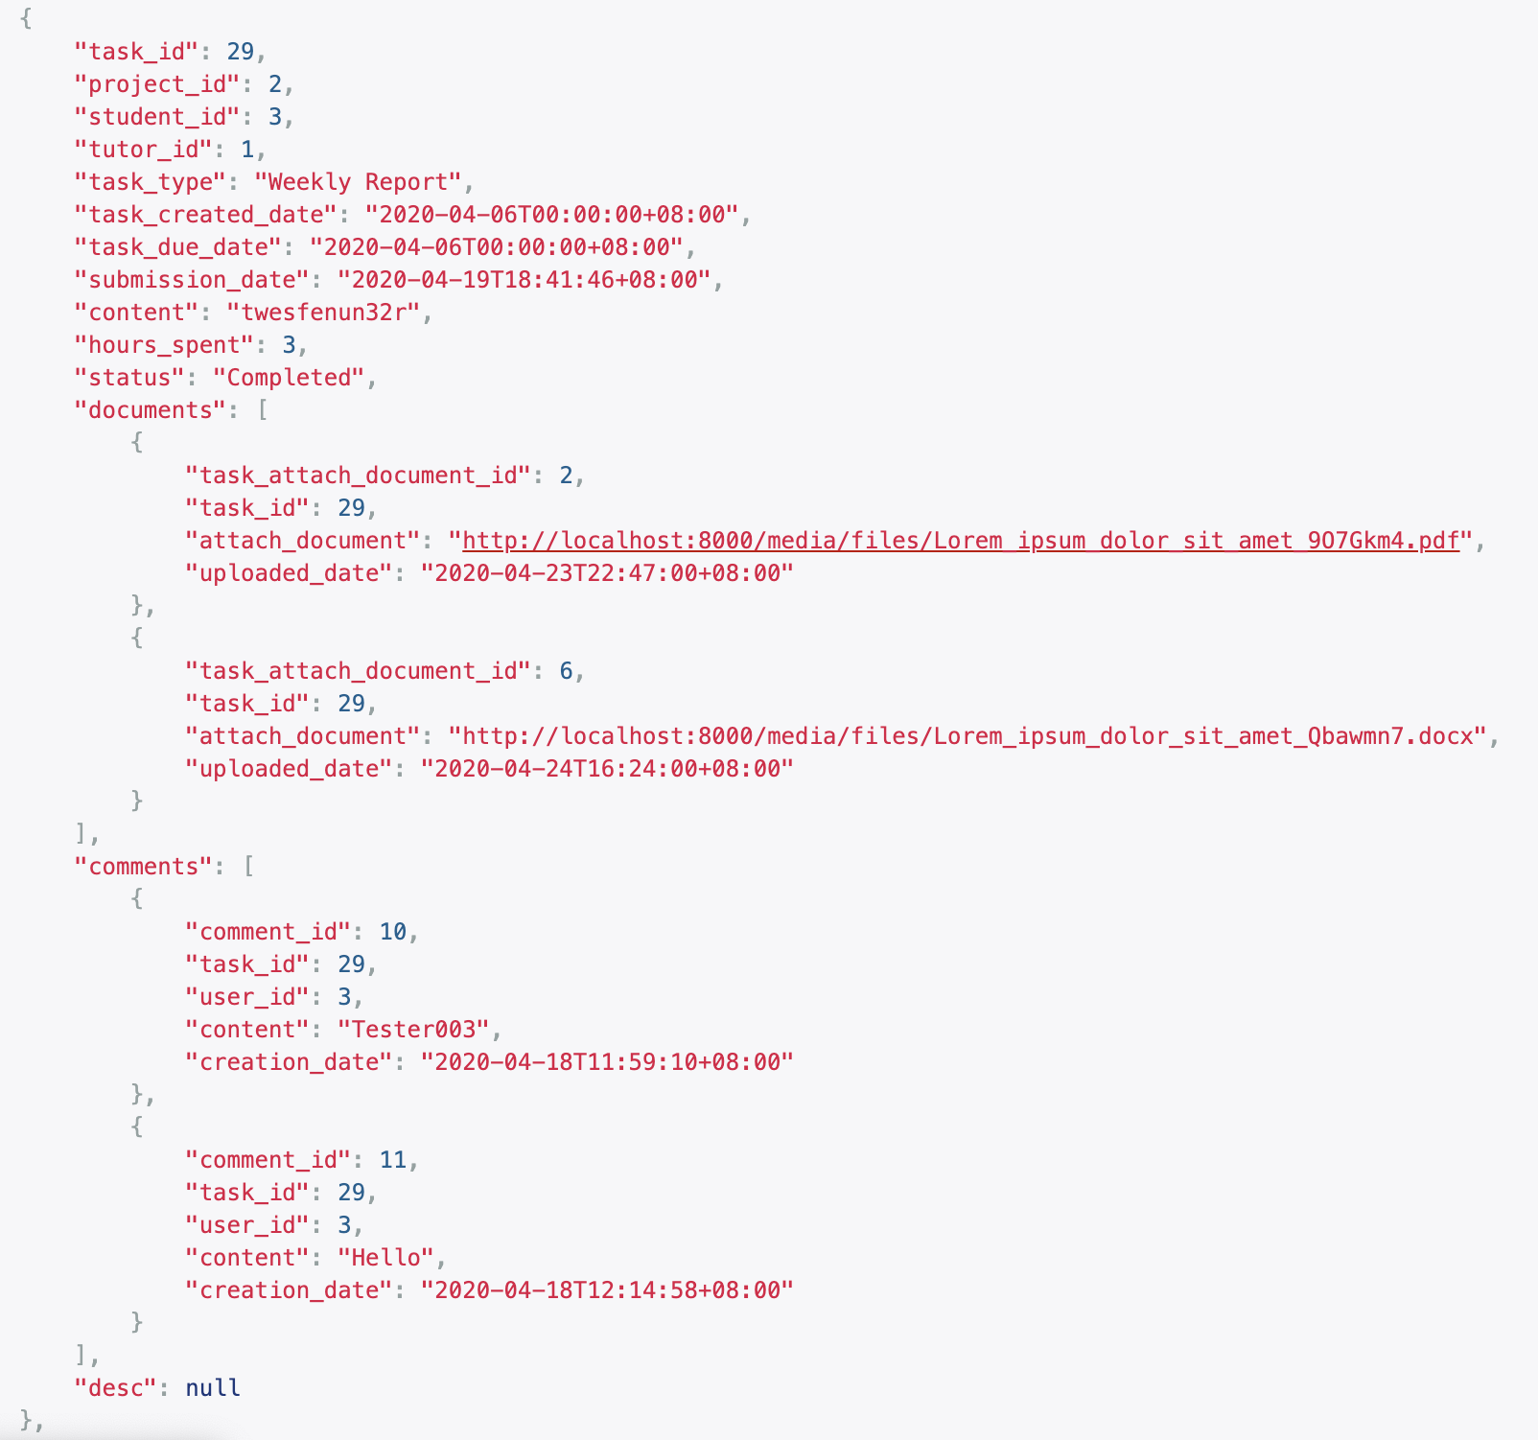

Figure 29: TaskComment API

If I’d like to only get a specific student’s tasks, I’d use a more specific URL: /api/taskComment/?student_id={student_id} where {student_id} is a variable that accepts integers and corresponds to the student’s ID.

To understand how to retrieve the data, let’s say I would like to get the status of this task, I simply do an axios.get with the URL and from the response, I have to do a:

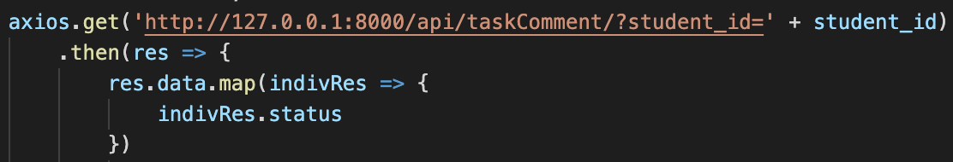

to access the API structure as seen in Figure 29.

Once I have gotten the data from each task, I will put it into the MobX store for use in multiple components.

### 4.2.3 Calendar View and Functionalities

Once a user is authenticated, the calendar view appears. Both the staff and student have different views and slightly different functionalities in each. Figure 30 shows the supervisor view and Figure 31 shows the student’s view.

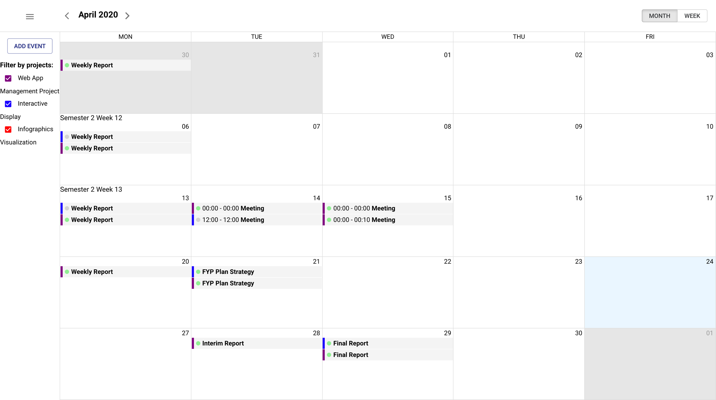

Figure 30: Supervisor Calendar

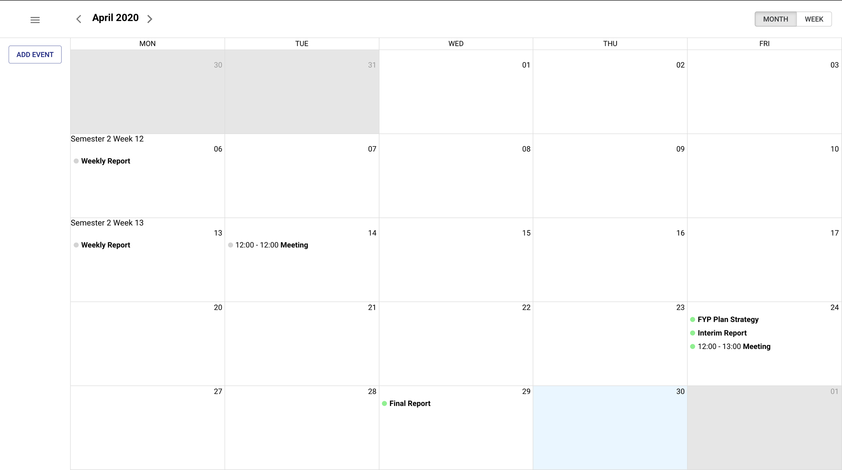

Figure 31: Student Calendar

#### 4.2.3.1 Similar Functionalities

##### 4.2.3.1.1 Adding and Deleting events

From the calendar, there are 2 ways of adding events:

1. Using the “Add Event” button on the left-hand side
2. Clicking on the date’s cell

Upon clicking, an event form will appear. There is only 1 difference between the supervisor and staff’s event view, which is the *Select Projects Involved* option, as seen in the figures below.

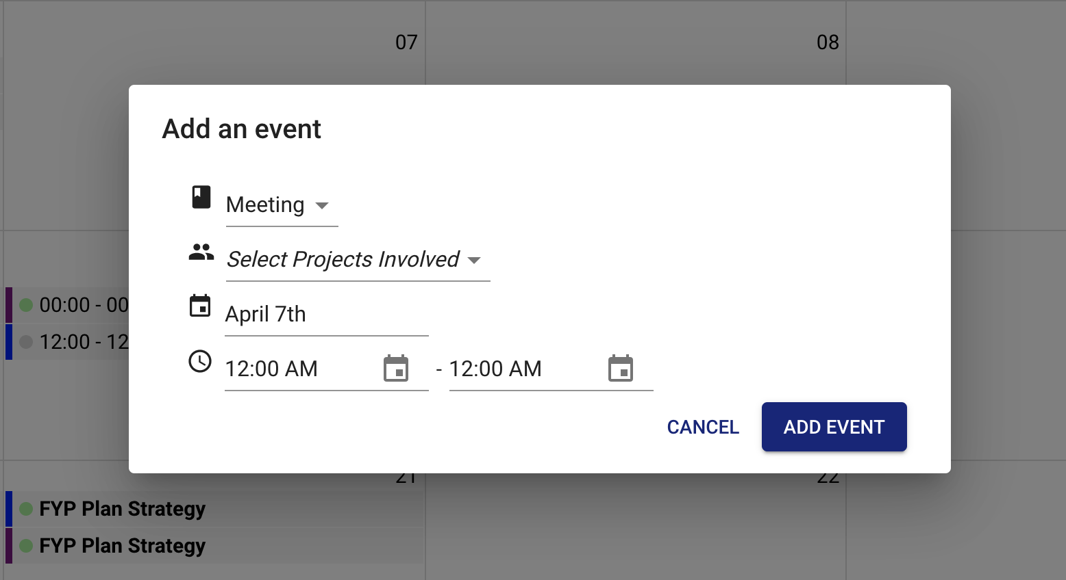

Figure 32: Supervisor's Add Event Form

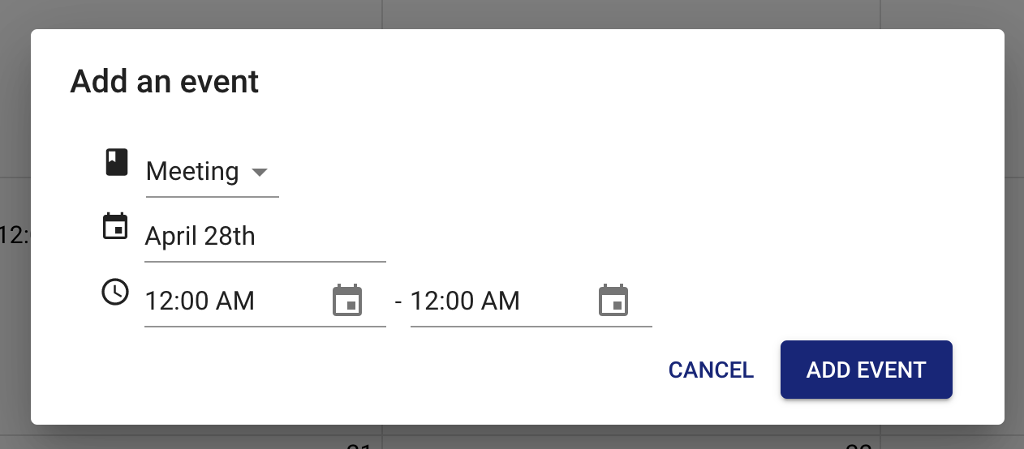

Figure 33: Student's Add Event Form

They can choose the type of task it is for and for supervisors, the projects that will be involved in this event.

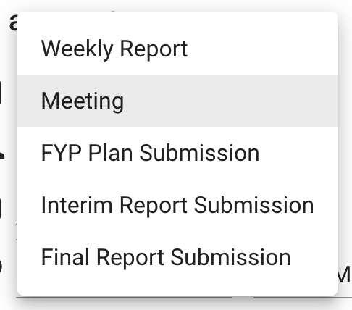

Figure 34: Types of events

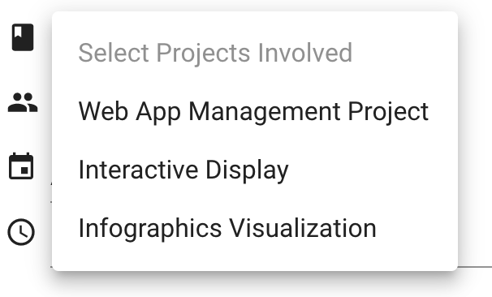

Figure 35: Types of projects (for Supervisor only)

This makes it easier for supervisors to set common deadlines across projects instead of having to add each one manually.

In order to delete events, they simply have to click on the event and a summarized view will appear as seen in Figure 36. Then they can just click on “Delete” and it’ll delete the events across all users involved.

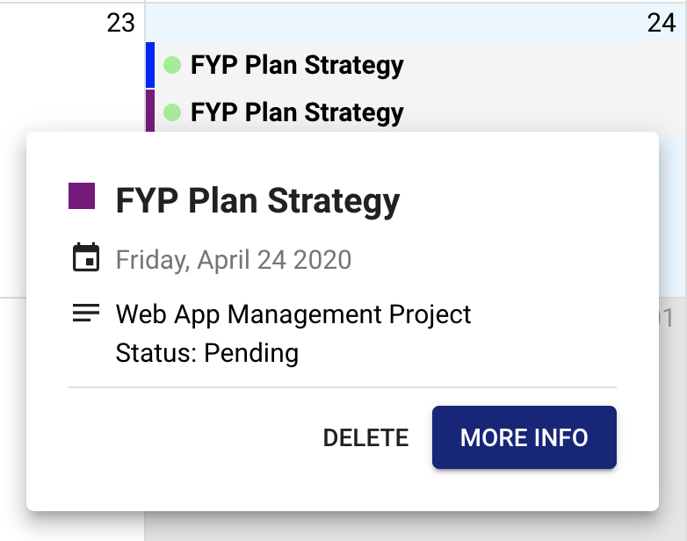

Figure 36: Summarized view of events

The exception here would be for the Strategy Plan, Final Report and Interim Report events. If the individual event has documents attached, the event will not be allowed to be deleted due to integrity checks.

##### 4.2.3.1.2 Summarized view of events

As mentioned, there were changes to the symbolism related to the events. From ticks and exclamation marks, the symbolism is simplified to a circle of different colors.

1. Completed: Grey
2. Late: Red
3. Late Submission: Yellow
4. Pending: Green

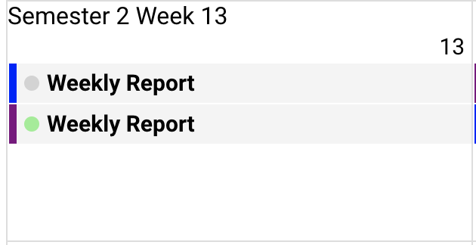

Figure 37: Simplified symbolism of events

This follows the ‘traffic-light’ colors to make it easier to understand based on context.

But to take into consideration color-blind users, in the summarized view of the event, the status will also be indicated.



Figure 38: Summarized view shows status

For example, the project name will appear (although for student it will not because they only have their own projects), the date and a visual confirmation of the status.

If they want to navigate to the reports page based on the event, they can do so by clicking on “More Info” (i.e. If a user clicks on a “Weekly Report” event, then on “More Info”, they will be rerouted to the Weekly Report view).

#### 4.2.3.2 Different Functionalities

As different types of users have different needs and purposes on the platform, there is a need to provide separate functions despite a similar interface.

##### 4.2.3.2.1 Left-Side Drawer

Although all users will have a left-side drawer at the top left corner of the calendar page, they have different functionalities.

For a supervisor, in their left-side drawer, they have access to Project Listings and a Logout button.

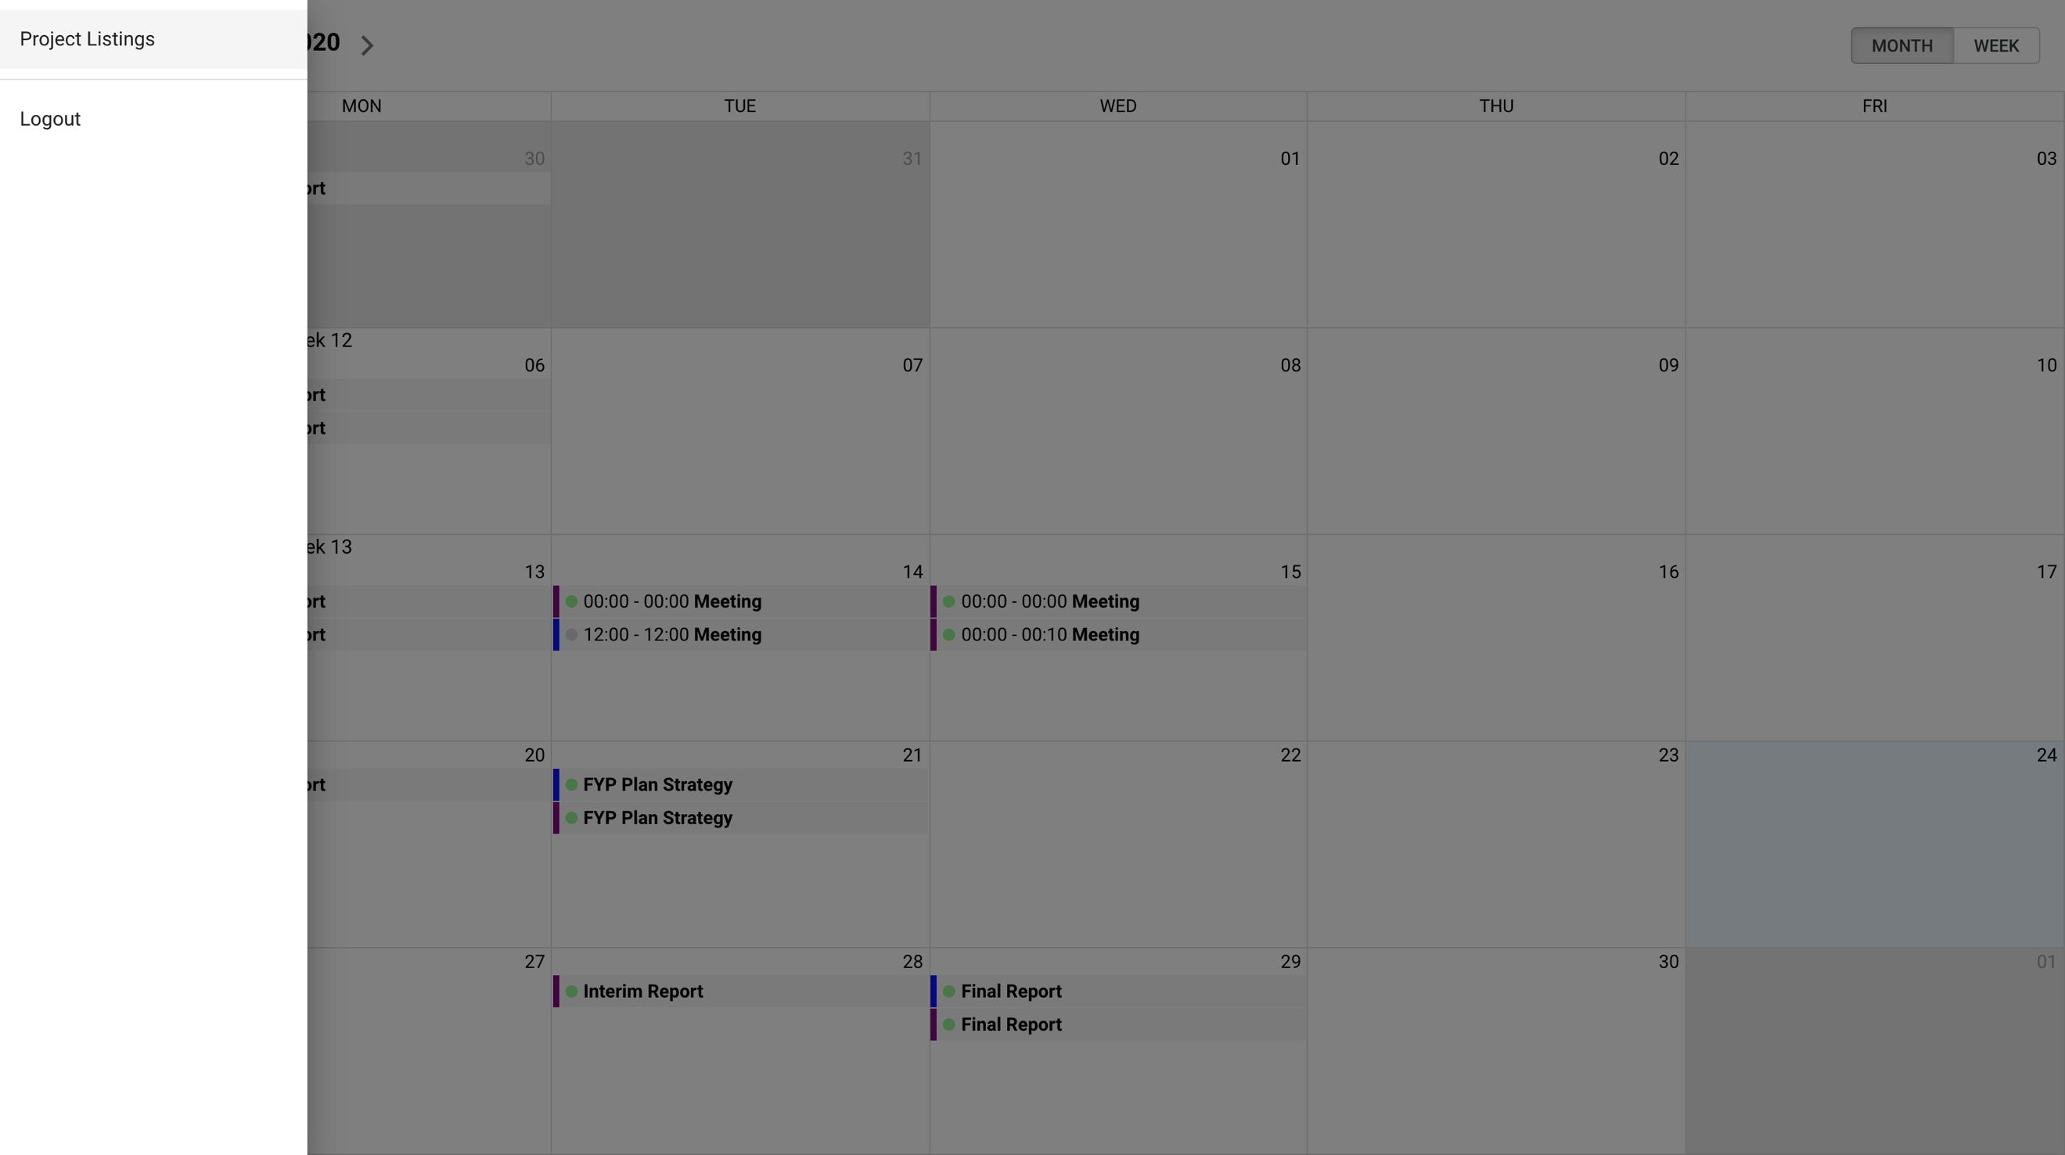

Figure 39: Supervisor's left-side drawer

For a student, they have access to the various report views and a logout button.

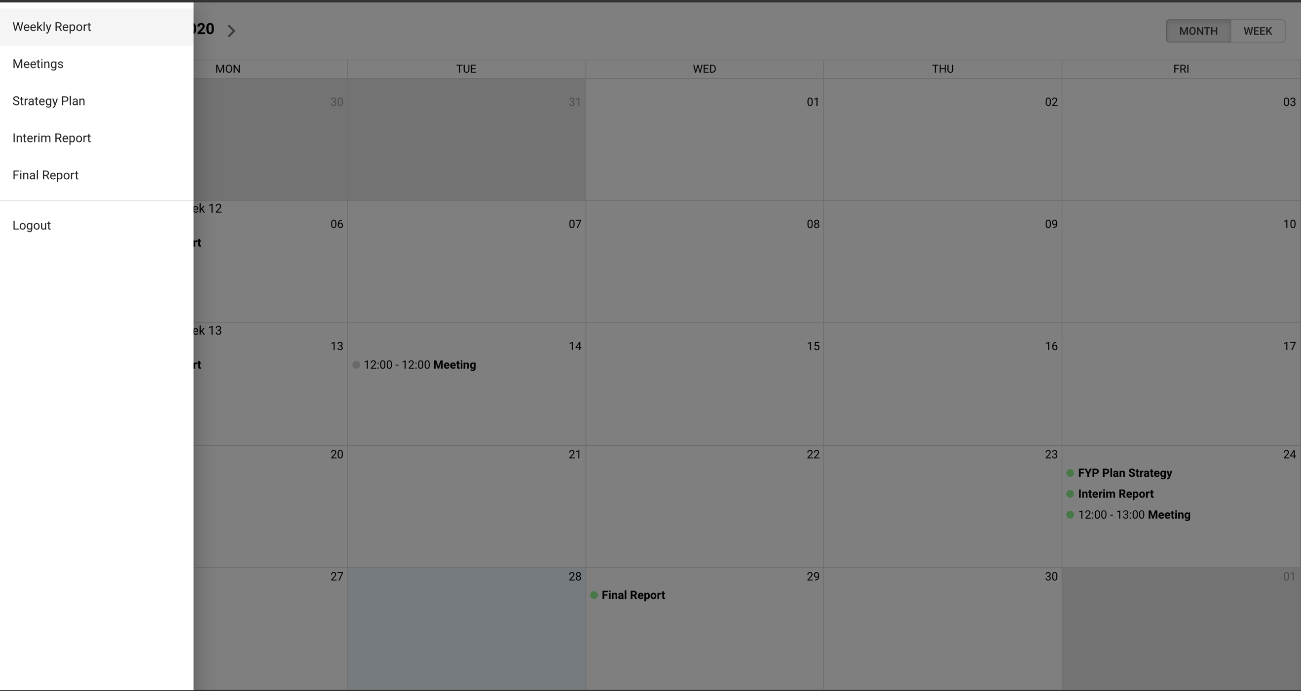

Figure 40: Student's left-side drawer

##### 4.2.3.2.2 Filtering of projects

This is a supervisor-only function as supervisors are potentially expected to handle many projects across the FYP and DIP students. Therefore, not only will the events be color-coded based on the project (e.g. one is purple, another is blue), there will be a filter in the left-side column that acts as (1) a filter of projects and (2) a legend – to let the supervisor know which color represents which project.

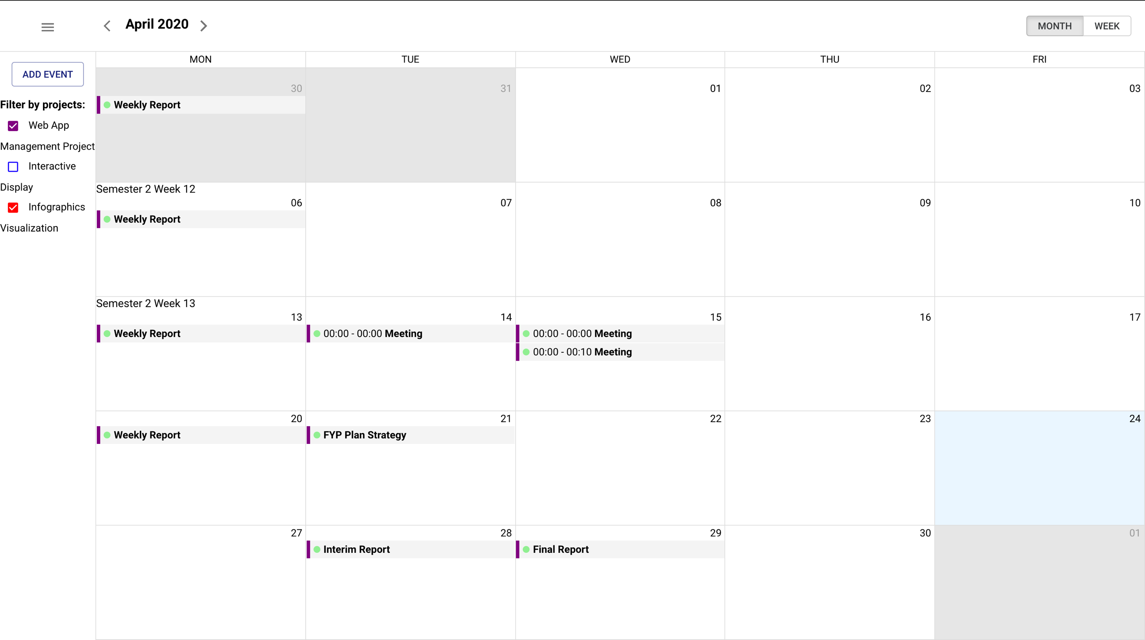

Figure 41: Supervisor filters out “Interactive Display”

With the added ability to filter through projects, it makes it easier for the supervisor to view different events, apart from the normal overview of all events.

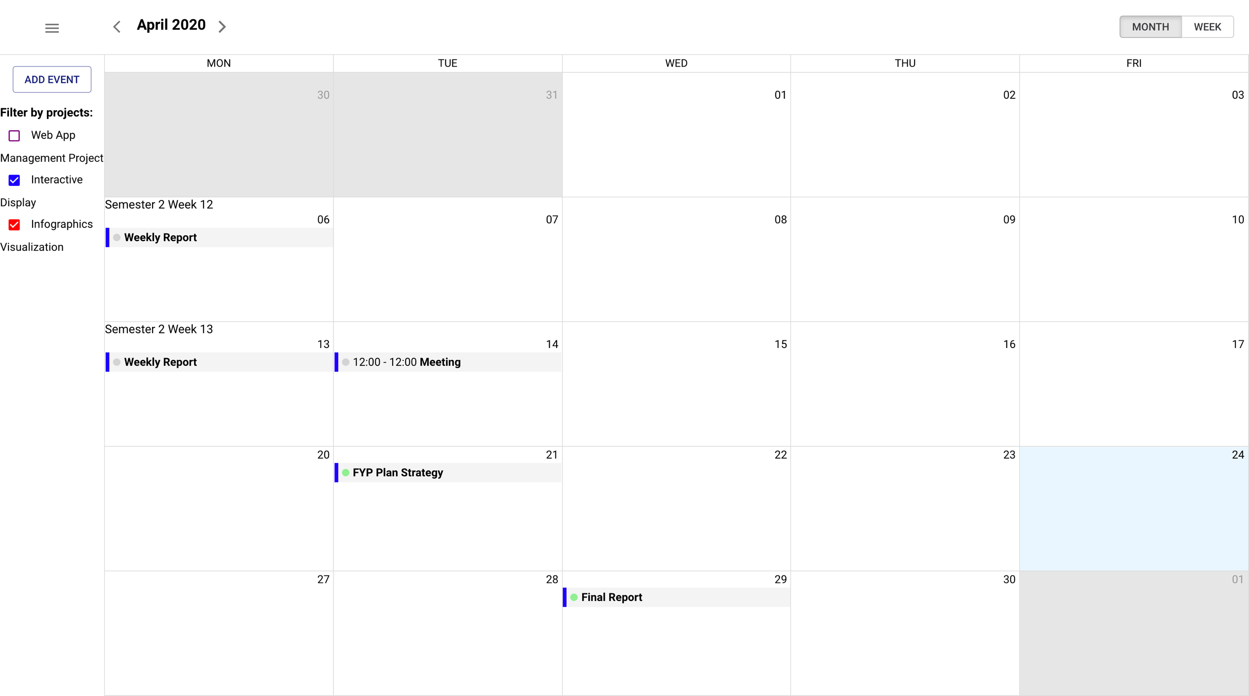

Figure 42: Supervisor filters out “Web App Management Project”

## 4.3 Reports View

For the reports view, as all the data would have been extracted from the URL /api/taskComment as mentioned in the previous section, we only have to extract information from the MobX store, instead of calling the API again. This reduces the load time when navigating into the components.

For the reports view, as there are similar functions across different report views, the table below shows an overview of which report has what functions.

Functions

Type of Report

|  |  |  |  |
| --- | --- | --- | --- |
|  | **Weekly Report** | **Meeting Notes** | **Other Submissions** |
| Write and Upload Content/Details **(students** **only)** | Yes | Yes | No |
| Upload Documents | Yes | Yes | Yes |
| View Uploaded Documents | Yes | Yes | Yes |
| Comment Capability | Yes | No | Yes |

Table 6: A comparison of type of reports to their functionalities

Note that deletion of tasks is only done in the main calendar view by means of deleting an event, and when deleting an event, it means deleting all the notes and documents attached to it.

### 4.3.1 Write and Upload Content

Being able to upload content based on the report is only available for students. The left side of the page for both weekly report and meeting notes are boxes for the student to fill up.

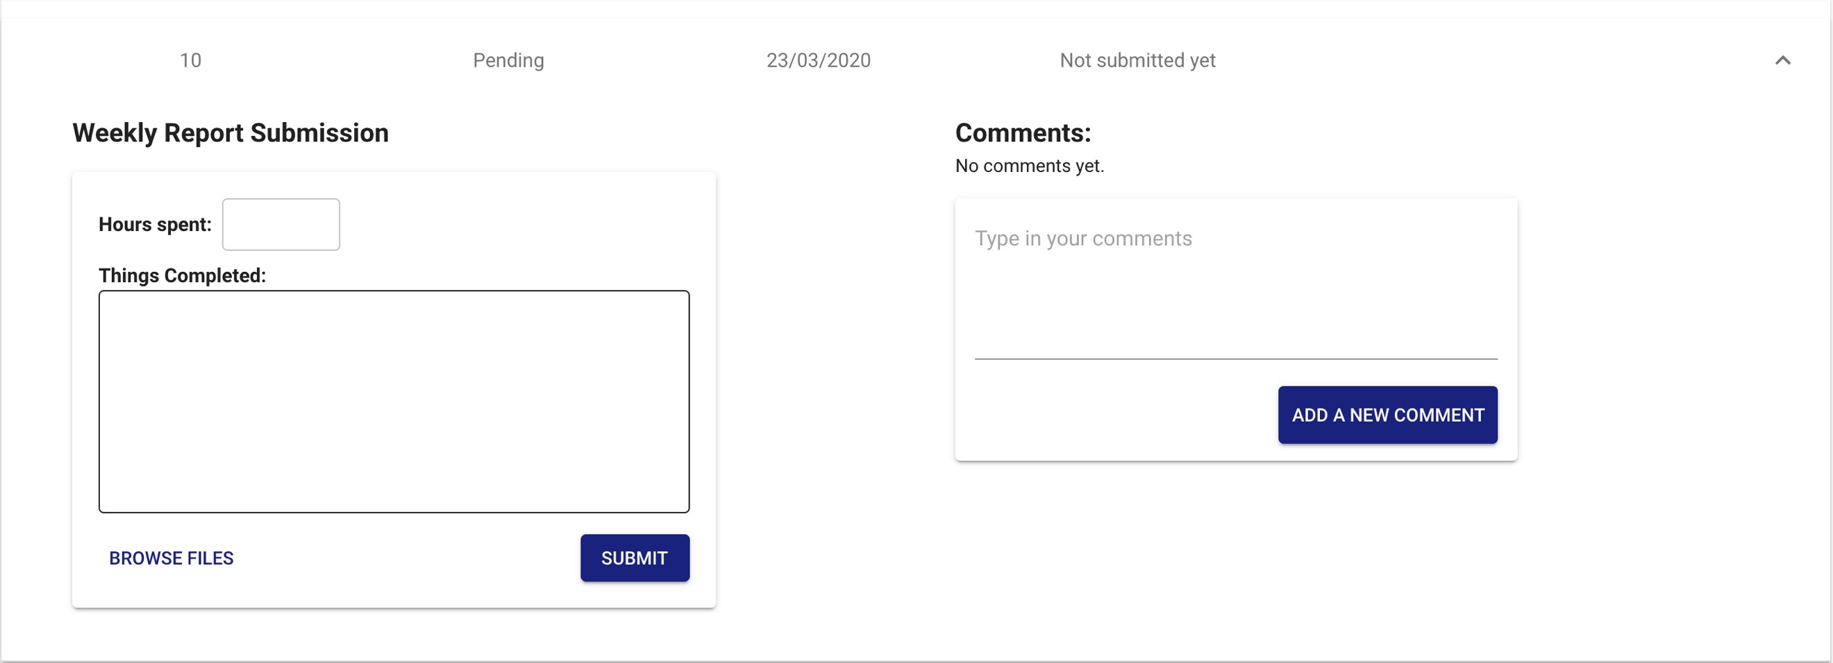

Figure 43: Student view of weekly report

For the professors though, they will only see a message if the student has yet to submit anything in that week, otherwise they’ll be able to see the content typed and documents attached (if any).

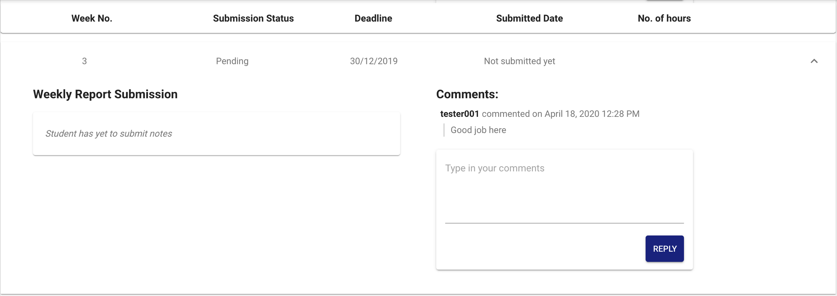

Figure 44: Supervisor view of weekly report

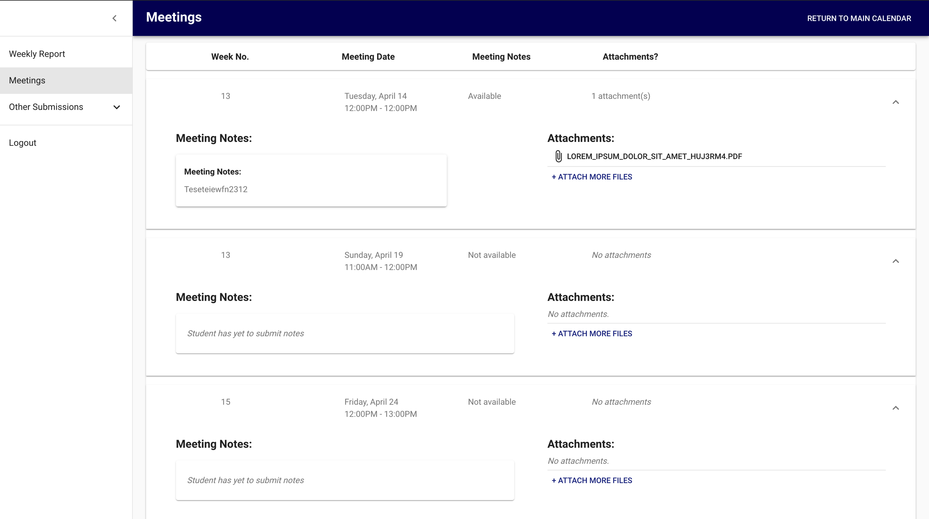

Figure 45: Supervisor view of meeting notes

As part of being able to write content, whenever a student inserts an *x* number of hours in their weekly report, the weekly report page’s top navigation will indicate the total number of hours the student has spent.

This allows the supervisor to quickly glance the total number of hours the student has spent on the project without having to go through every single task.

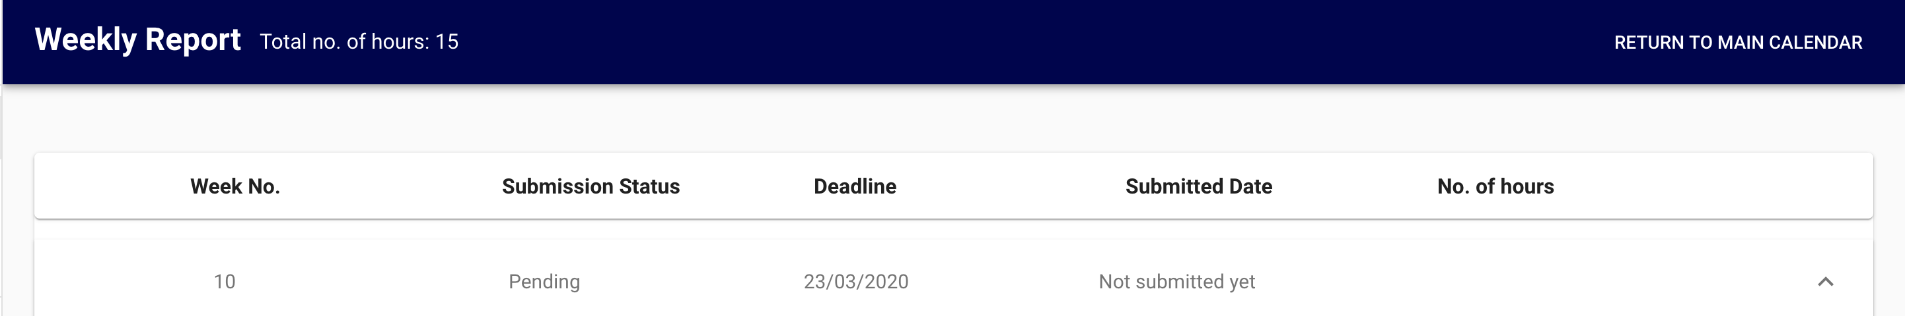

Figure 46: Displaying total number of hours

### 4.3.2 Uploading Documents

Students can upload documents as they write the content in both weekly report and meeting notes. After a report is submitted, both students and supervisors can opt to upload documents by clicking the “Attach More Files” button.

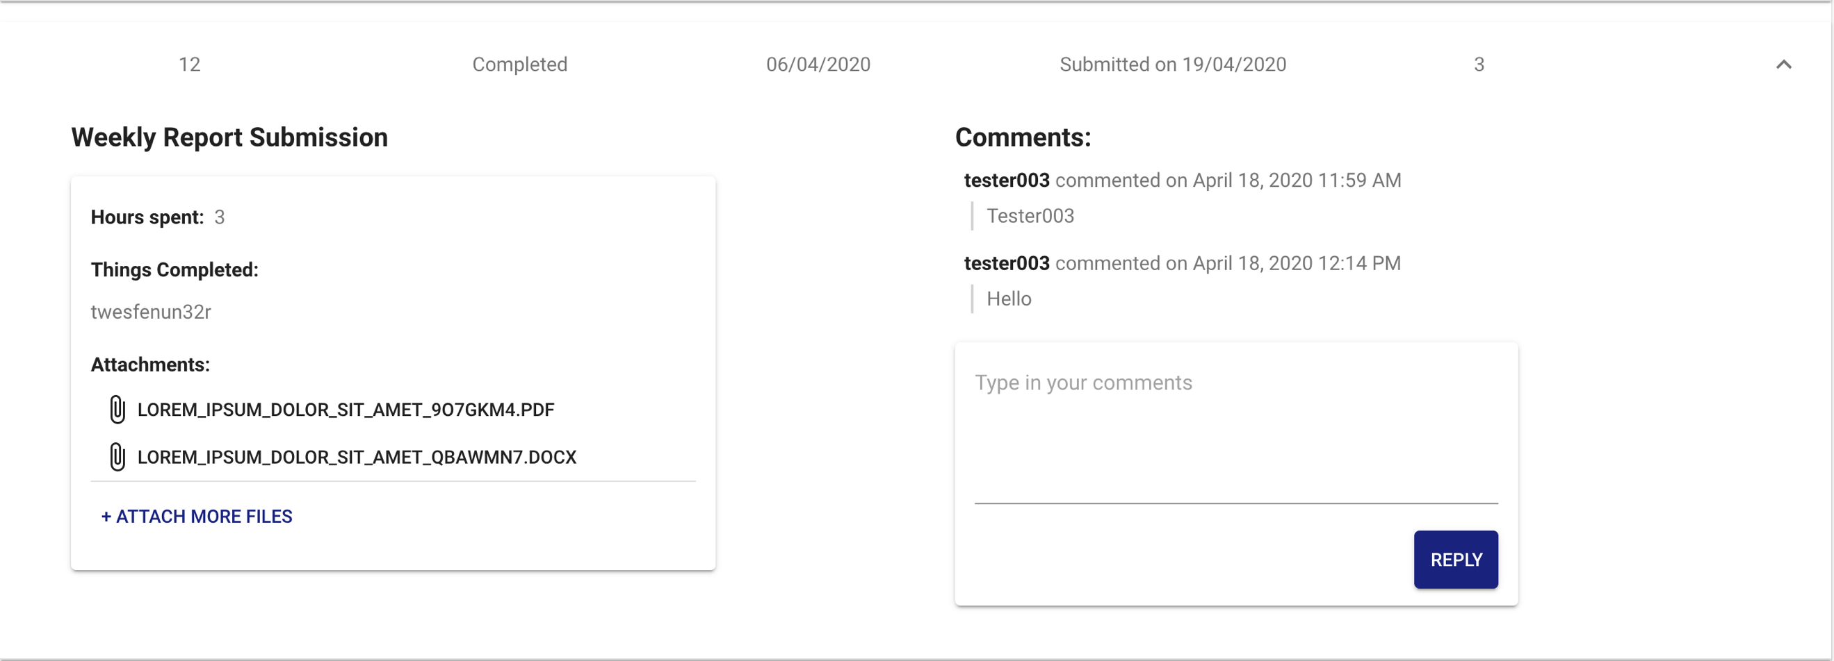

Figure 47: Uploading more documents after submission

The view changes to reflect any additional files. And the user can opt to upload it to the database, else cancel their attached files.

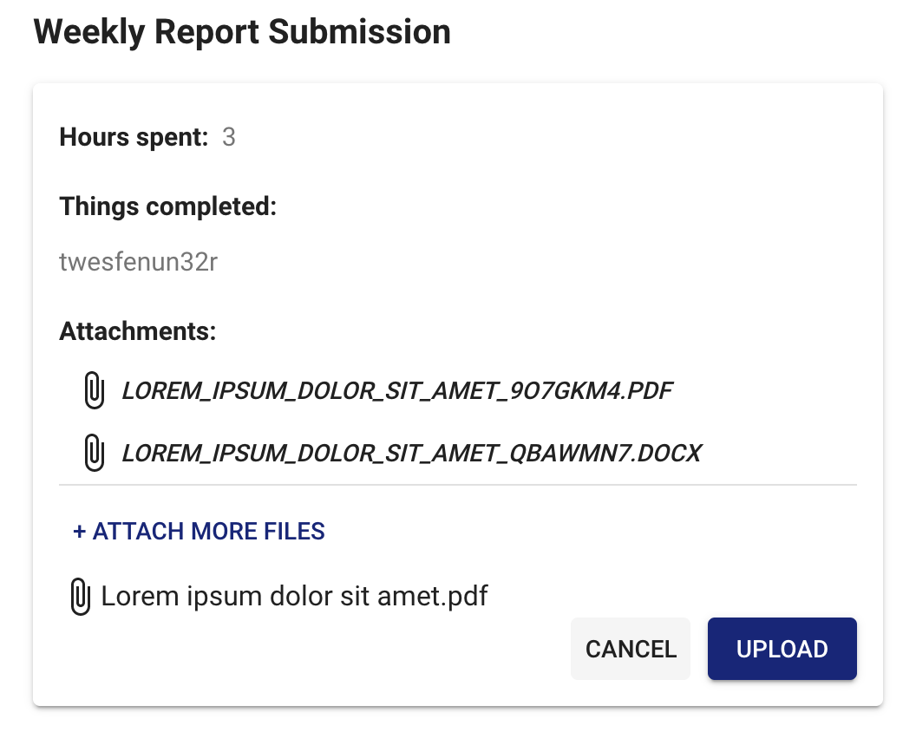

Figure 48: More files are uploaded

### 4.3.3 View Uploaded Documents

With the help of react-pdf and react-file-viewer, after a document has been added to the system, the user can easily view it by clicking on the file name.

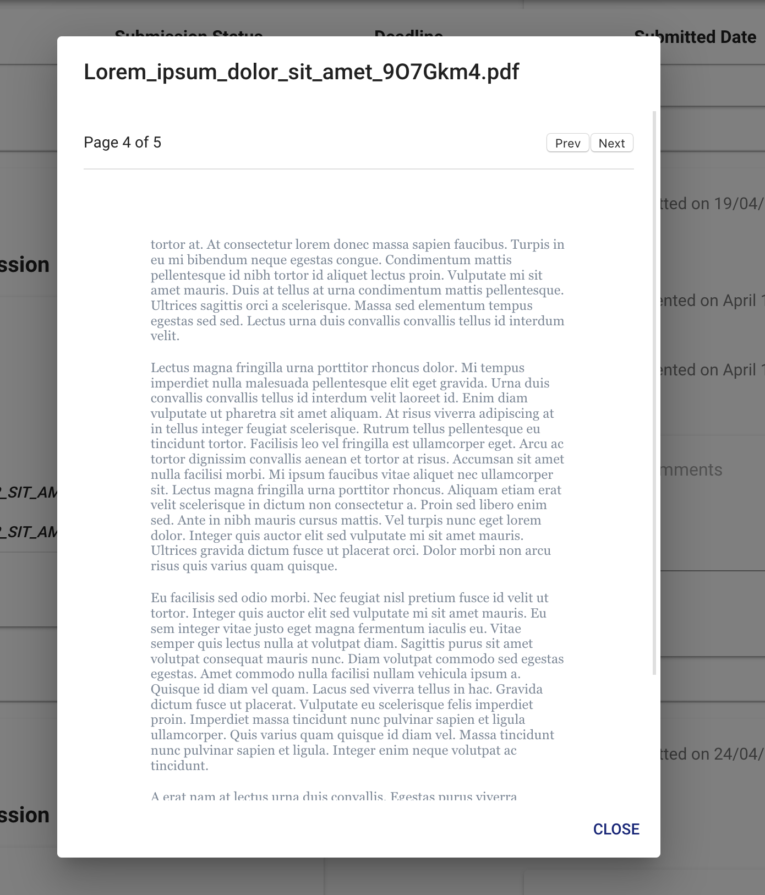

Figure 49: The .pdf view when opened up

A .pdf file is different from a .docx file as it can reflect page numbers. A .docx is instead an infinite scroll until the end of the document is reached.

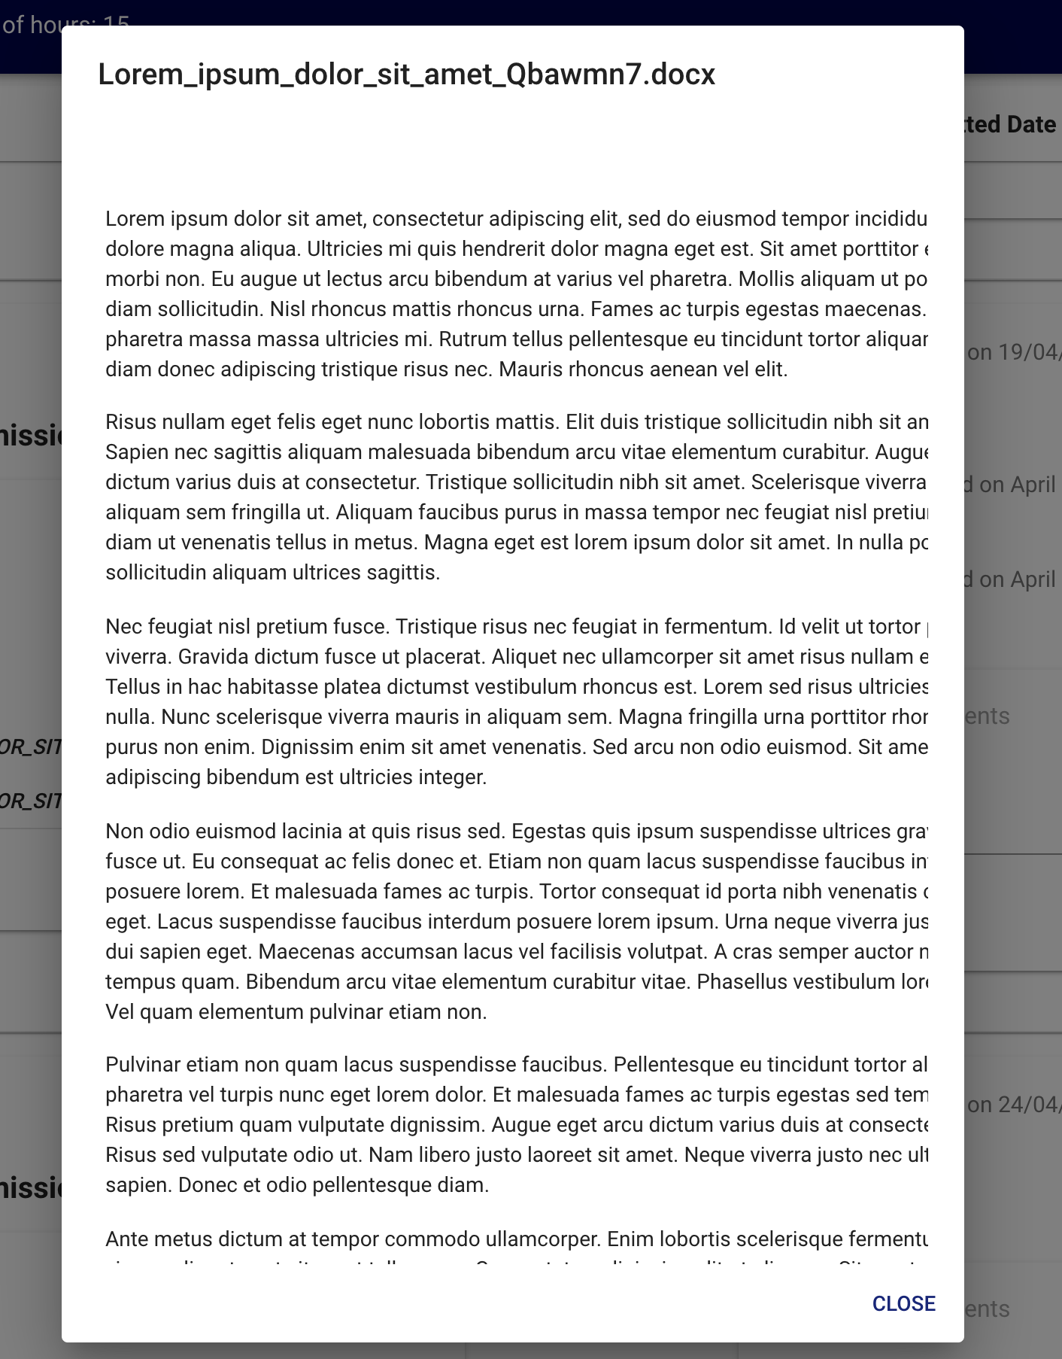

Figure 50: The .docx view when opened up

### 4.3.4 Comment Section

The comment section allows for 2-way communication between the student and the supervisor.

In order to save the comment, we need to axios.post to another API called /api/comment/ and pass through the user’s ID, the task’s ID, the content of the comment and the time when the comment was posted to the server.

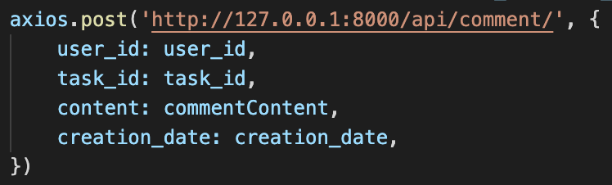

This way, anyone who commented on this specific task will be able to view all the comments as seen below.

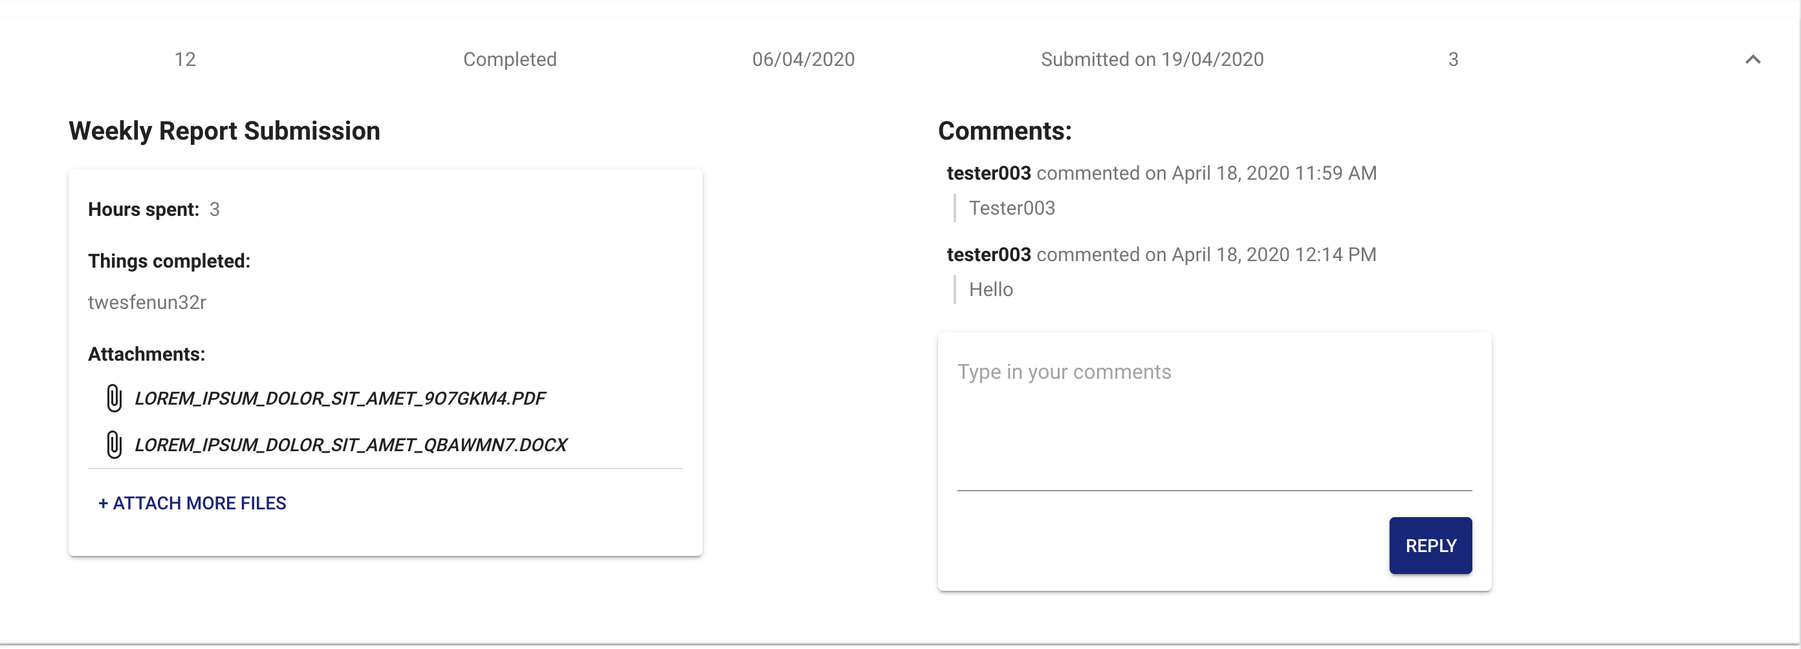

Figure 51: Viewing of comments

The comment’s button will also change depending on whether there are comments or not. For example, if there are no comments, the button’s prompt changes to “Add a new comment”. And once there are comments, it changes to “Reply”.

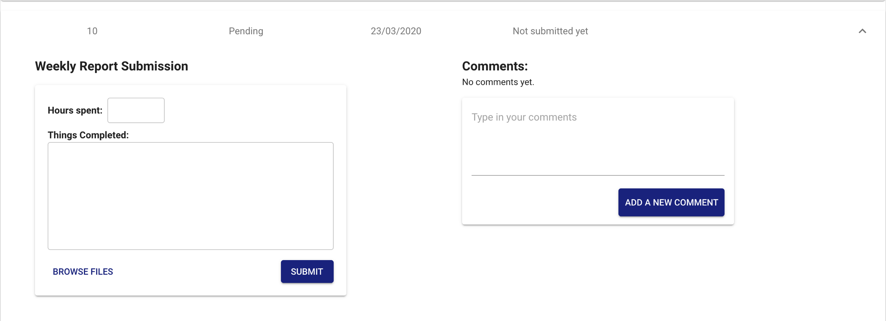

Figure 52: Comment button before comments are added

This increases user experience as they are better prompted to know what to do.

Although the comment section is a reusable component seen in all parts but the meetings, the way they are presented is somewhat different.

As initially discussed in section 3.2.2.3.3, the plan for the Other Submissions view was to allow multiple comments on 1 document regardless of task type (i.e. one Interim Report document can have 3 comments, another Interim Report can have 5).

However, due to API restrictions, comments are tied to their *task’s ID* rather than the document’s ID, following the API call discussed above.

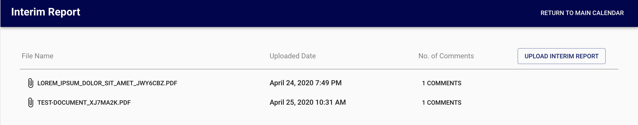

Figure 53: API ties all comments to 1 task instead of document ID

Thus, 1 task type can have multiple documents added but the same number of comments across all the documents as shown above.

This meant a tweak in terms of implementation where the comment section is now an overall of all the comments related to the event itself.

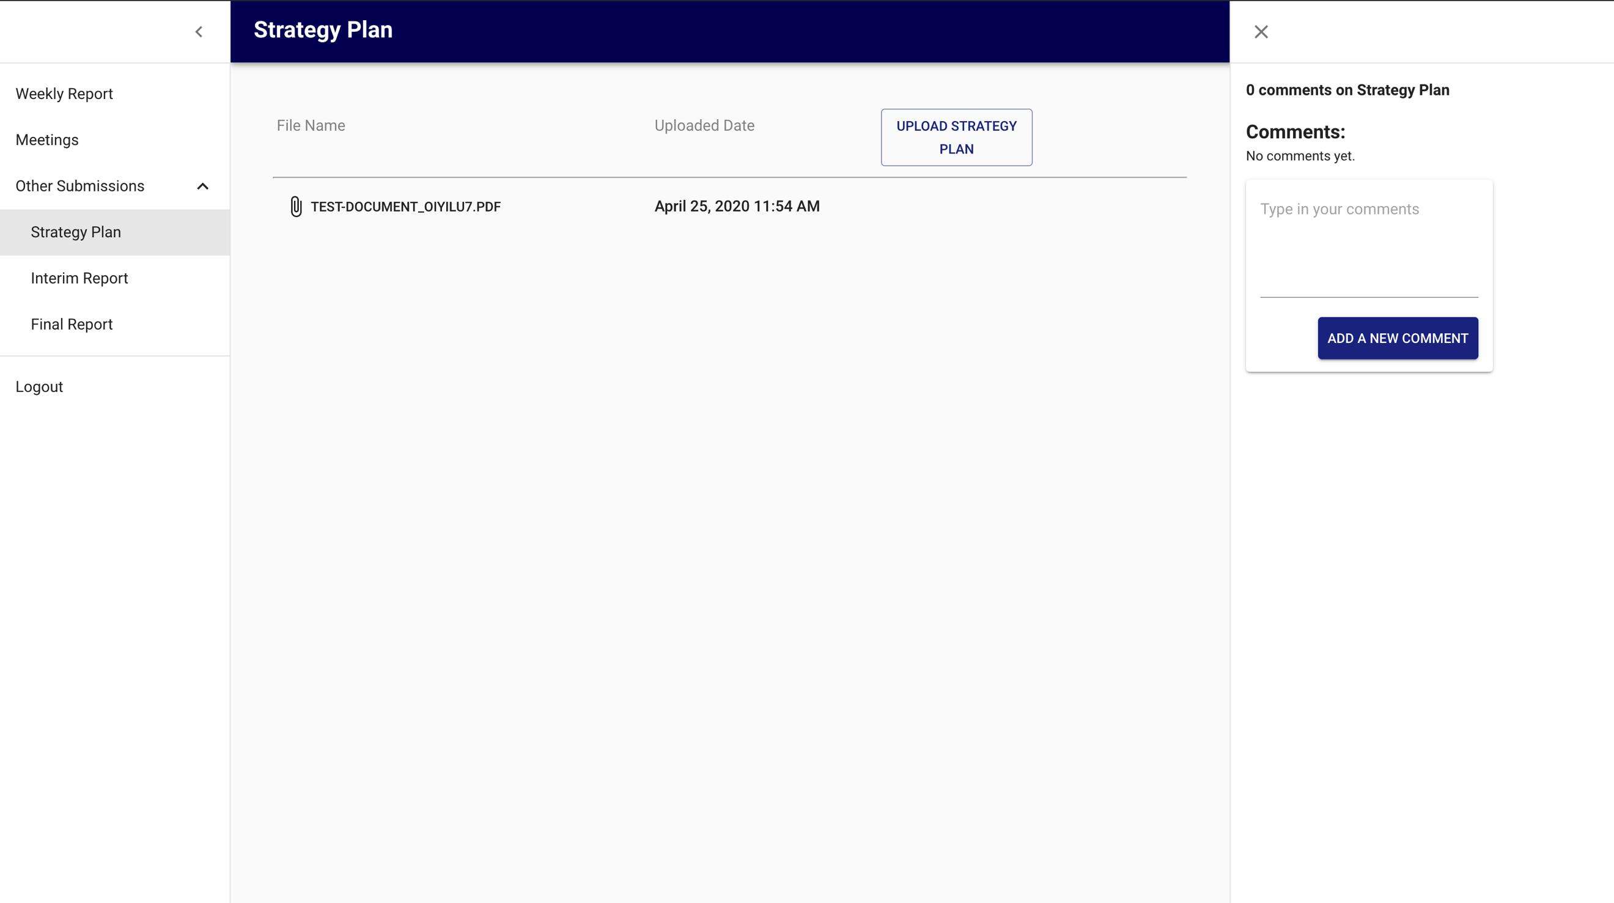

Figure 54: Multiple documents, 1 comment section

It is placed inside a right-side drawer that will appear on load-in but has the option to be closed. If the drawer is closed, simply click on the “View Comments” button to reopen the drawer of comments.

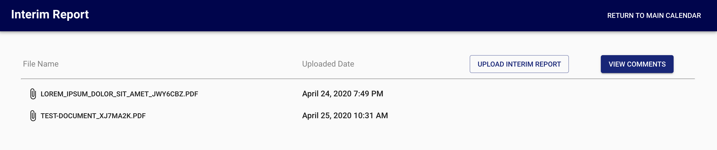

Figure 55: View when comment section is closed

# 

# Conclusions and Future Work

## 5.1 Conclusions

With the abundance of project management platforms being produced, we can see that there is an increasing need for such platforms especially when it comes to one suited for NTU supervisors in charge of FYPs and DIPs. Thus, in terms of producing the interface for a platform targeted at NTU supervisors taking charge of FYP or DIP groups, the project has fulfilled the following requirements:

1. Single-Page Application (SPA) using ReactJS
2. Optimal navigation system, likely a 3-click to destination rule
3. Overview of all calendar-based events and statuses
4. Ability to create, update and delete tasks and events
5. File sharing system for relevant documents to be shared
6. Comment section for any task for all users
7. And overall a simple and user-friendly interface that meets all the defined requirements for the system

The interface uses the Material-UI framework for the clean design components and ReactJS along with Axios to allow the interface to interact with the backend system by means of an API. This has allowed the effortless setup of displaying the calendar events, updating tasks, deleting of events, uploading of documents and commenting on tasks.

## 5.2 Recommendation in Future Work

Due to the limited time constraint, certain features that can be added to future work includes:

### 5.2.1 Notification System

Being able to notify users of any updates to the system such as an addition of a new event/task or a new comment added, would easily turn their attention to pressing notifications and address them without accidentally missing out on them as they use the platform.

### 5.2.2 Automatic Update of Statuses

Although this is technically towards the backend in which for my part of the project, was not my major concern, but being able to update the events’ statuses automatically would be a great help towards allowing the statuses to reflect accurately based on date and time.

### 5.2.3. Announcements System

In order to make an even more personalized project management platform for NTU professors, having an announcement system to relay key information that can be referenced in the future like instructions for an upcoming submission would be an excellent addition.

# References

1. N. Norruddin, “Thinking Schools, Learning Nation,” *Singapore Infopedia*, 07-May-2018. [Online]. Available: https://eresources.nlb.gov.sg/infopedia/articles/SIP_2018-06-04_154236.html. [Accessed: 2020].
2. “Microsoft Outlook for business,” *Microsoft*. [Online]. Available: https://www.microsoft.com/en-sg/microsoft-365/outlook/outlook-for-business.
3. “Introduction to Material Design,” *Material Design*. [Online]. Available: https://material.io/design/introduction#goals.
4. “Understanding typography,” *Material Design*. [Online]. Available: https://material.io/design/typography/understanding-typography.html#type-properties.
5. J. Kyrnin, “Balance: the Basic Principles of Design,” Lifewire, 14-Nov-2019. [Online]. Available: https://www.lifewire.com/balance-design-principle-3470048.
6. M. Soegaard, “Repetition, Pattern, and Rhythm,” The Interaction Design Foundation, 2018. [Online]. Available: https://www.interaction-design.org/literature/article/repetition-pattern-and-rhythm. [Accessed: 2020].
7. S. Bradley, “Design Principles: Dominance, Focal Points And Hierarchy,” Smashing Magazine, 27-Feb-2015. [Online]. Available: https://www.smashingmagazine.com/2015/02/design-principles-dominance-focal-points-hierarchy/. [Accessed: 2020].
8. J. Hensley, “Improve Your Designs With The Principles Of Similarity And Proximity (Part 1),” Smashing Magazine, 03-May-2016. [Online]. Available: https://www.smashingmagazine.com/2016/05/improve-your-designs-with-principles-similarity-proximity-part-1/. [Accessed: 2020].
9. “React – A JavaScript library for building user interfaces,” A JavaScript library for building user interfaces. [Online]. Available: https://reactjs.org/. [Accessed: 2020].
10. “Material UI: A popular React UI framework,” Material UI. [Online]. Available: https://material-ui.com/. [Accessed: 2020].
11. “What is an API? (Application Programming Interface),” *MuleSoft*. [Online]. Available: https://www.mulesoft.com/resources/api/what-is-an-api. [Accessed: 2020].
12. A. Amador, “How to make HTTP requests using Fetch API and Promises,” Medium, 08-Jan-2019. [Online]. Available: https://medium.com/@armando_amador/how-to-make-http-requests-using-fetch-api-and-promises-b0ca7370a444. [Accessed: 2020].
13. J. Arnold, “Fetch vs. Axios.js for making http requests,” Medium, 10-Feb-2017. [Online]. Available: https://medium.com/@thejasonfile/fetch-vs-axios-js-for-making-http-requests-2b261cdd3af5. [Accessed: 2020].
14. “Component State - React,” React. [Online]. Available: https://reactjs.org/docs/faq-state.html. [Accessed: 2020].
15. EDUCBA, “Mobx vs Redux: Top 8 Useful Differences You Should Know,” EDUCBA, 23-Apr-2020. [Online]. Available: https://www.educba.com/mobx-vs-redux/. [Accessed: 2020].
16. “Moment.js,” Moment.js | Home. [Online]. Available: https://momentjs.com/. [Accessed: 2020].
17. J. Bourn, “Meaning of The Color Blue,” *Bourn Creative*, 15-Jan-2011. [Online]. Available: https://www.bourncreative.com/meaning-of-the-color-blue/. [Accessed: 2020].
18. N. Babich, “7 Things To Remember When Selecting Fonts For Your Design,” Medium, 21-Apr-2019. [Online]. Available: https://uxplanet.org/7-things-to-remember-when-selecting-fonts-for-your-design-ec1e592266c5. [Accessed: 2020].